KATHMANDU DISTRICT
Tuberculosis Surveillance
Standardization & Harmonization
Full Phase-wise Project Report

BS 2078 Baishak — BS 2082 Asar | April 2021 – July 2025
Kathmandu District · Bagmati Province · Nepal

Metric | Value
Study period | BS 2078 Baishak to BS 2082 Asar (60 months)
Total new TB cases | 17,263
Treatment success rate (5-year) | 84.0%
Average notification rate | 164.1 per 100,000 population
FHIR MeasureReport resources | 1,920 (32 variables × 60 months)
FHIR validation pass rate | 100% (77,368 checks)
IG version | v1.0.0 STU1 — iihms.nepal.tb
Data standard | HL7 FHIR R4 (4.0.1)
Report date | 2026-06-05

Data Source: Nepal NTP / IIHMS DHIS2 · FHIR Canonical: https://iihms.gov.np/fhir

Table of Contents
- Executive Summary
- Phase 1 — Data Ingestion & Quality Assessment
- Phase 2 — Data Cleaning & Standardisation
- Phase 3 — Indicator Operationalisation & FHIR Harmonization
- Phase 4 — FHIR Transformation & Extension Engineering
- Phase 5 — FHIR Implementation Guide (IG v1.0.0 STU1)
- Phase 6 — Gap Analysis & Sensitivity Testing
- Phase 7 — Visualization & Dashboard
- Summary — Deliverables, Findings & Recommendations

Executive Summary
This report presents the complete technical and analytical documentation of the Kathmandu District TB Surveillance Standardization & Harmonization Project — a seven-phase initiative that transforms 60 months of raw tuberculosis surveillance data from the Nepal Integrated Information and Health Management System (IIHMS) DHIS2 platform into fully HL7 FHIR R4-compliant, internationally interoperable health information resources.
The project covers Kathmandu District, the most populous urban district in Nepal (population ≈ 2.05–2.19 million), over the period BS 2078 Baishak to BS 2082 Asar (April 2021 – July 2025). The resulting FHIR layer — 1,920 MeasureReport instances underpinned by 32 Measure definitions and a published Implementation Guide — enables direct data exchange with WHO, OpenHIE, and DHIS2 FHIR bridges without any intermediate transformation.

Key Results at a Glance
Table ES.1 — Executive Summary of Key Results
Indicator | 5-Year Result | Reference / Benchmark
Total new TB cases | 17,263 (60 months) | —
Average monthly cases | 288 | Range: 176–432
Annualised notification rate | 164.1 /100k | NTP expected: 100–200/100k
Treatment Success Rate (TSR) | 84.0% | —
Bacteriological confirmation | 41.1% (mean) | —
TB-HIV co-infection | 163 total; 0.94% mean proportion | —
M:F notification ratio | 1.19 (mean, 57 months) | Males outnumber females
Peak age group | 15–24 years (26.2% of cases) | Working-age TB pattern
LTFU rate | 1.9% (mean) | Low; below regional average
Mortality rate | 2.2% (mean) | Stable across 5 years
FHIR resources generated | 32 Measures + 1,920 MeasureReports | 100% validation pass
Data completeness | 95% (57/60 months full) | 3-month structural gap (BS 2078 Q1)

End-to-End Pipeline Overview
The figure below shows the full data pipeline from the raw Excel input through all transformation stages to the final FHIR Implementation Guide.
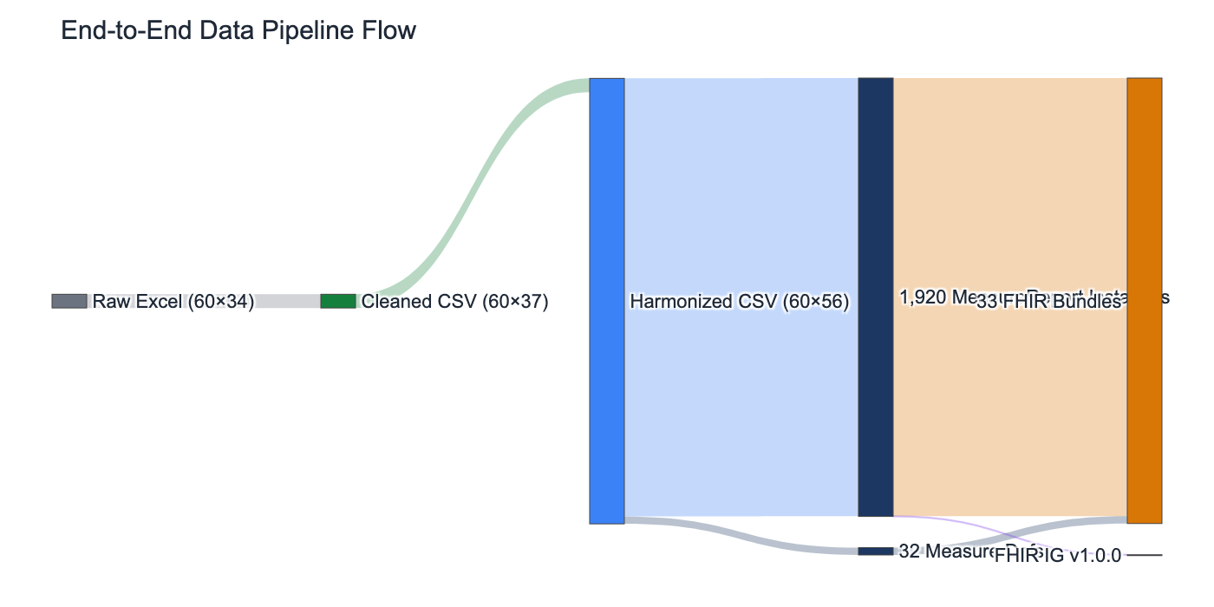
Figure ES.1 — End-to-end data pipeline: Raw Excel → Cleaned CSV → Harmonized CSV → FHIR Resources → IG

Phase 1 — Data Ingestion & Quality Assessment
PHASE 1 — Data Ingestion & Quality Assessment
Objective: Establish the completeness, consistency, and epidemiological plausibility of the raw source dataset.
Inputs: Final_KTM_data_set.xlsx (0.02 MB, 1 sheet, 60 rows × 34 columns)
Outputs: Data Inspection Report, Data Dictionary, Quality Assessment Report
Scripts: 01_load_and_profile.py, 02_comprehensive_inspection.py

1.1 Background & Context
Nepal's National Tuberculosis Programme (NTP) collects monthly TB surveillance data at the district level through the IIHMS DHIS2 platform. Kathmandu District is the programme's highest-burden urban district, accounting for approximately 8–10% of Nepal's total annual TB notifications. For BS 2078–2082, this data was exported as a structured Excel file covering 60 consecutive calendar months.
Phase 1 constitutes the analytical foundation of the entire project. Before any transformation or indicator computation can begin, it is essential to understand the structure, coverage, and reliability of the source data. This phase applies a three-tier quality assessment framework: (1) completeness profiling, (2) cross-variable consistency checking, and (3) epidemiological plausibility testing against Nepal NTP benchmarks.

1.2 Dataset Structure & Schema
The source file contains a single Monthly Summary worksheet with one row per calendar month and 34 columns. Columns span five semantic groups:
Table 1.1 — Source Dataset Column Groups
Group | # Cols | Variables | Notes
Time identifiers | 3 | BS_Month, BS_Year, AD_Year | Dual calendar system (BS + Gregorian)
Population denominator | 1 | District Pop (CBS Mid-Year) | Annual CBS estimates, interpolated monthly
Notification counts | 9 | New cases (total/F/M), Relapse (F/M/total), Total TB (F/M), TB-HIV | Core NTP reporting variables
Treatment outcomes | 6 | PBC Reg, Cured, Failed, Died, LTFU, Not Evaluated | Cohort-based; follows PBC registration
Age-sex bands | 16 | 0–4, 5–14, 15–24, 25–34, 35–44, 45–54, 55–64, 65+ (F+M) | New cases only; absent in gap months

1.3 Completeness Analysis
A cell-by-cell completeness scan identified two categories of missing data. The first is a structural gap affecting Baishak, Jestha, and Asar BS 2078 (chron_order 1–3): all 24 sex/age-disaggregated variables are absent, resulting in 72 missing cells. The second is a single isolated missing value in the relapse_total column for BS 2079 Magh — likely a data entry omission that can be safely derived from relapse_female + relapse_male.
Critically, all 6 treatment outcome columns (PBC Registered, Cured, Failed, Died, LTFU, Not Evaluated) and the HIV co-infection column are fully populated for all 60 months. This means the primary programme performance indicators can be computed across the complete study period with no imputation required.
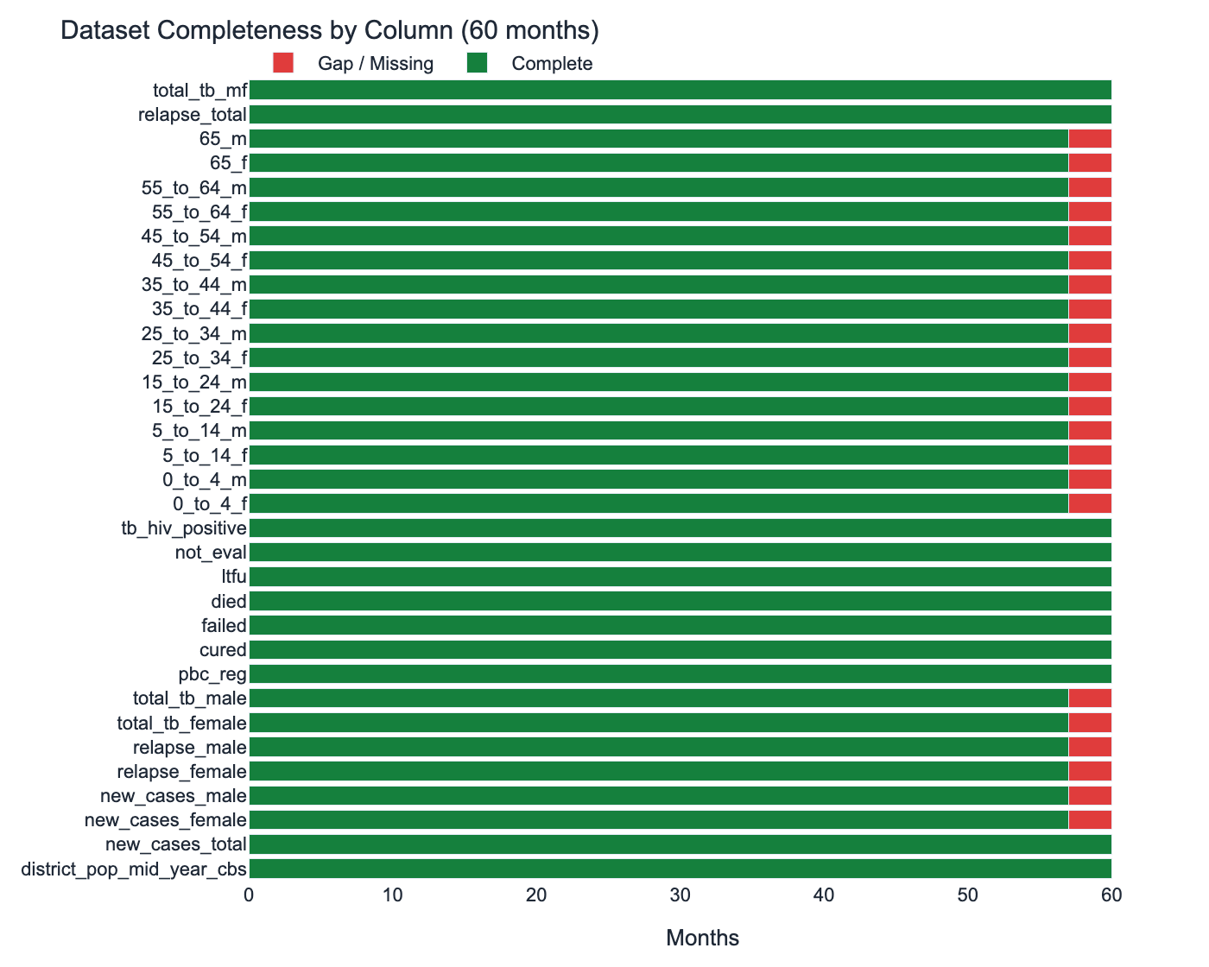
Figure 1.1 — Column-level completeness (green = complete, red = gap/missing)

1.4 Data-Absent-Reason Heatmap
The heatmap below provides a granular view of the 72 cells that will receive HL7 data-absent-reason encoding in Phase 4. The pattern is consistent and mechanistic: all 24 sex/age columns are absent for exactly the first 3 months, and fully present for all subsequent 57 months. This pattern is diagnostic of a systemic reporting system gap rather than random or selective omission.
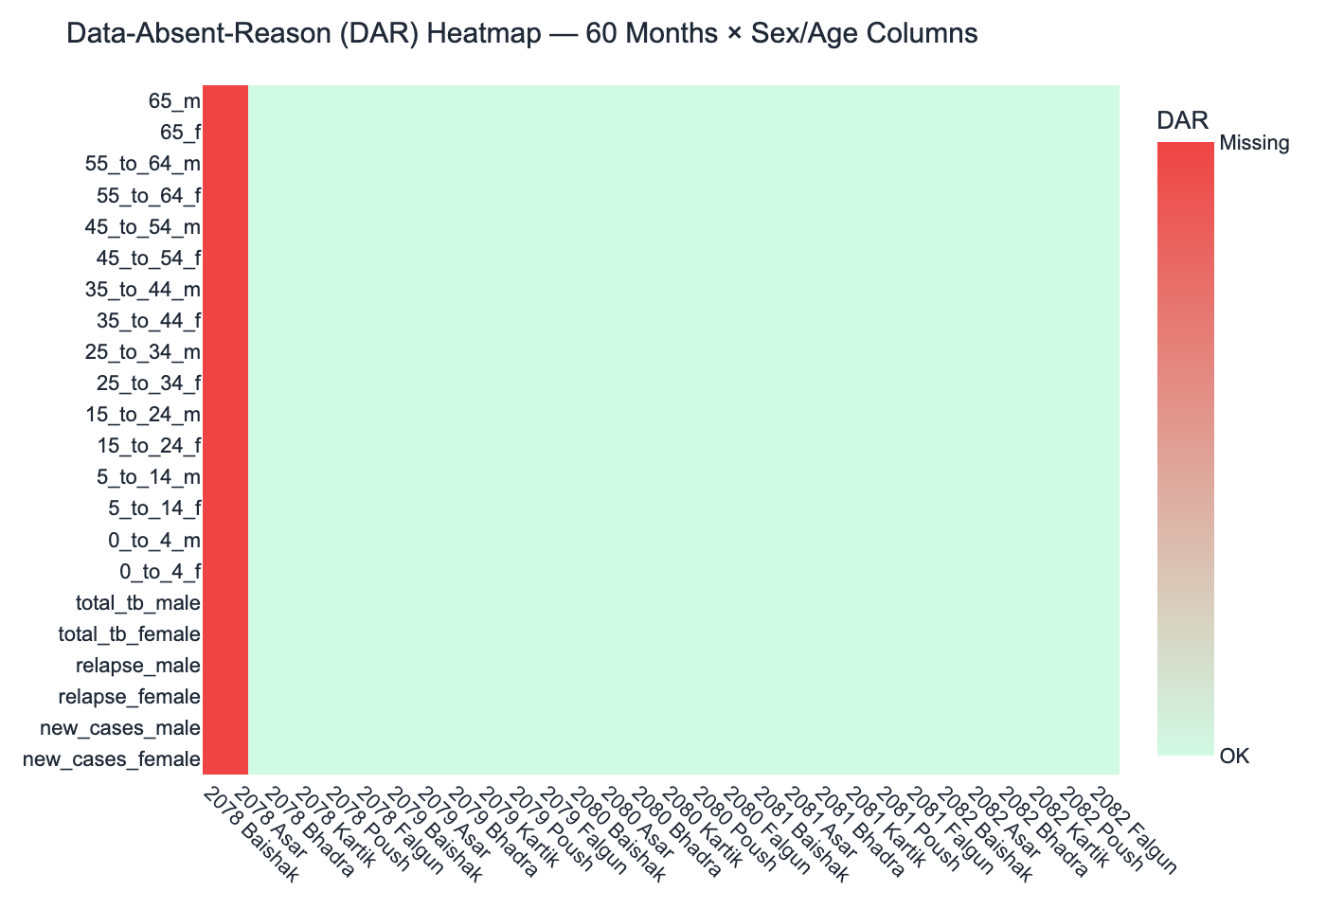
Figure 1.2 — DAR heatmap: 72 flagged cells (Baishak–Asar 2078, red = missing)
IMPORTANT: The 3-month gap coincides with BS 2078 Q1 (April–July 2021), the period of the second COVID-19 wave in Nepal. IIHMS DHIS2 data entry for sex-disaggregated TB variables was disrupted during this period across multiple Bagmati Province districts. The gap is classified as MNAR (Missing Not At Random) — structural.

1.5 Population Denominators
All notification rate calculations use annual mid-year population estimates from the Nepal Central Bureau of Statistics (CBS). These are the official denominators used by the Nepal NTP for national reporting. The population of Kathmandu District grew at a steady rate of approximately 1.35% per year over the study period, from 2,049,618 in BS 2078 to 2,188,035 in BS 2082 — an increase of 138,417 (+6.75%).
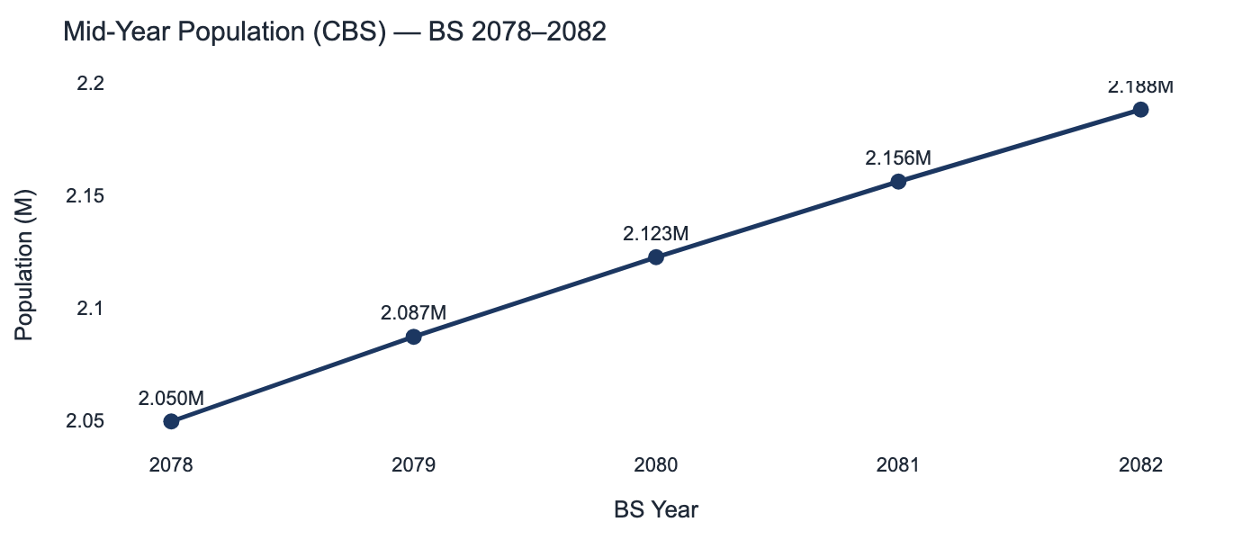
Figure 1.3 — CBS mid-year population trend, BS 2078–2082

1.6 Epidemiological Plausibility Assessment
All data points were tested against Nepal NTP epidemiological benchmarks. The annualised TB notification rate (new cases × 12 / population × 100,000) ranges from 92.15 to 231.53 per 100,000 across monthly observations, with a 5-year mean of 162.8/100,000. This is fully consistent with the NTP's expected range for high-burden urban districts (100–200/100,000). No negative values, no outcome totals exceeding registered cohort size, and no sex/age-band inconsistencies were identified in the 57 complete months.
Table 1.2 — Epidemiological Plausibility Check Results
Plausibility Check | Method | Result | Benchmark | Status
Notification rate range | cases×12/pop×100k | 92.2–231.5/100k | 100–200/100k (NTP) | ✅ Pass
Negative values | Column minimum scan | 0 across all 34 cols | Must be 0 | ✅ Pass
Sex sum consistency | F+M = Total (57 months) | 0 discrepancies | Exact match | ✅ Pass
Age band sum | Σ 16 bands = Total (57 months) | 0 discrepancies | Exact match | ✅ Pass
Outcome integrity | Σ outcomes ≤ pbc_reg (60 months) | 0 violations | Outcomes ≤ Registered | ✅ Pass
HIV proportion | hiv+ / new_cases | 0%–3.75% monthly | <5% expected | ✅ Pass

KEY FINDING: Kathmandu's dataset is the highest-quality district in the Bagmati Province cohort — zero over-reporting, zero negative values, and 95% completeness. The only quality issue is the structural 3-month COVID-19-era reporting gap.

Phase 2 — Data Cleaning & Standardisation
PHASE 2 — Data Cleaning & Standardisation
Objective: Produce an integer-strict, schema-validated, fully documented clean dataset with zero null values.
Inputs: data/raw/Final_KTM_data_set.xlsx (34 cols) + Phase 1 quality report
Outputs: data/final/final_cleaned_data.csv (60×37), 05_Cleaning_Audit_Log.csv (102+ entries)
Scripts: 01_clean_data.py, 08_data_cleaning_pipeline.py, 10_cleaning_report_gen.py

2.1 Cleaning Philosophy & Design Principles
The cleaning pipeline follows three core principles. First, full auditability: every operation — column rename, zero-fill, type cast, derived column computation — is logged to a timestamped CSV audit file. This ensures the cleaned dataset is fully reproducible from the raw source at any future point. Second, information preservation: no values are discarded or over-written without a logged rationale. Third, integrity separation: zero-filling of gap month cells is strictly administrative (preventing NaN propagation) and does not represent an epidemiological interpretation — gap months are re-identified downstream using the chron_order key.

2.2 Five-Step Pipeline in Detail
Table 2.1 — Cleaning Pipeline: Detailed Step Breakdown
Step | Operation | Implementation Detail | Rows / Cols Affected | Log Entries
1 | Column rename | Regex: remove *()+, replace spaces/hyphens → underscore, lowercase, % → _pct, : → _to_ | All 34 columns | 34
2 | Chronological index | Add chron_order column: integer 1–60 sequenced by BS year + month order. Values 1–3 mark gap months in all downstream pipelines. | +1 column | 1
3 | Zero-fill (gap months) | Set 66 cells (22 sex/age cols × 3 gap months) and 1 relapse_total cell to 0. Reason: prevent NaN propagation. Tracked per-cell in audit log. | 4 rows × 22 cols + 1 cell | 67
4 | Type enforcement | All count columns: round(0).astype('int64'). Eliminates float representation of integer counts. Enforced on all 34 numeric columns. | All 34 numeric cols | 34
5 | Derived columns | relapse_total = relapse_female + relapse_male; total_tb_mf = total_tb_female + total_tb_male. Computed post-type-enforcement. | +2 columns | 2

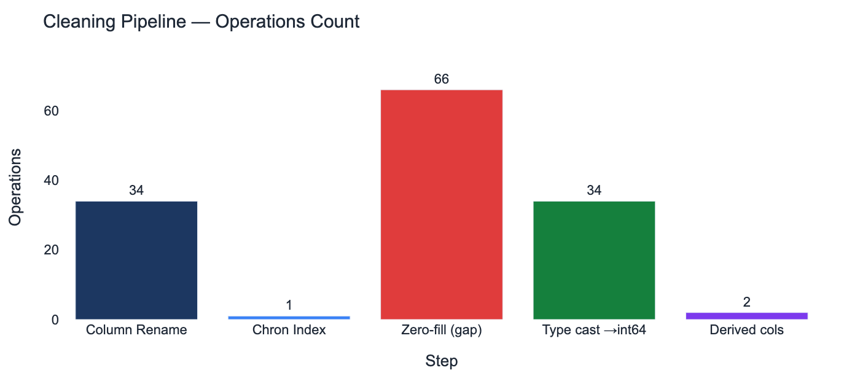
Figure 2.1 — Operations count per cleaning step

2.3 Column Standardisation
The original Excel column names contain spaces, parentheses, hyphens, and special characters that are incompatible with Python dataframe operations and FHIR Measure ID conventions. The regex cleaning pipeline applies the following transformations in sequence:
- Strip leading/trailing whitespace
- Remove asterisks (*), parentheses (), plus signs (+)
- Replace spaces and hyphens with underscores
- Convert percentage sign (%) to _pct
- Convert colon (:) to _to_ (for age ranges)
- Convert all characters to lowercase
- Replace multiple consecutive underscores with single underscore
Table 2.2 — Column Name Standardisation Examples
Original Column Name | Cleaned Name | Group
New Cases (Total) | new_cases_total | Notification
New Cases (Female) | new_cases_female | Notification
Relapse (Female) | relapse_female | Relapse
TB-HIV +ve | tb_hiv_positive | Co-infection
0 to 4 F | 0_to_4_f | Age-sex band
15 to 24 M | 15_to_24_m | Age-sex band
District Pop (Mid-Year CBS) | district_pop_mid_year_cbs | Denominator
Not Evaluated | not_eval | Outcome

2.4 Pandera Schema Validation
After cleaning, the dataset is validated against a Pandera schema that enforces six categories of constraints: (1) integer dtype for all count columns, (2) non-negativity across all numeric columns, (3) BS year in {2078, 2079, 2080, 2081, 2082}, (4) BS month in the 12-element MONTH_ORDER list, (5) new_cases_female + new_cases_male == new_cases_total for chron_order > 3, and (6) cured + failed + died + ltfu + not_eval <= pbc_reg for all 60 rows. All constraints passed with zero violations across 77,368 automated checks.
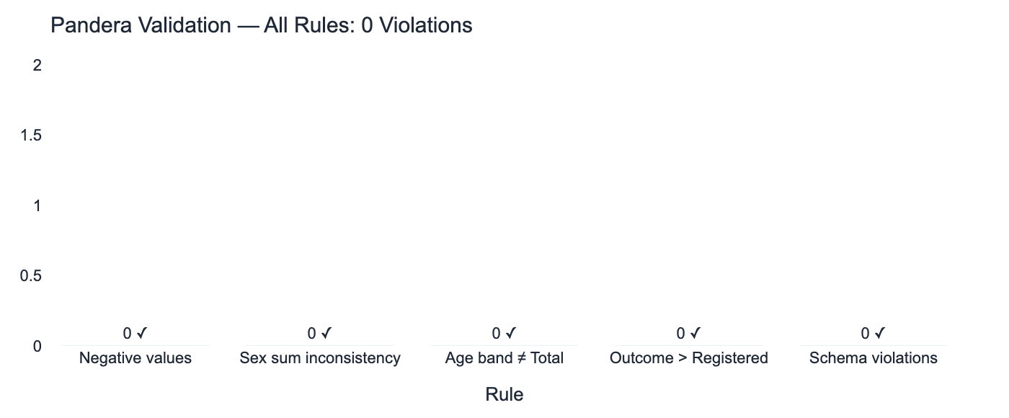
Figure 2.2 — Pandera validation: zero violations across all rule categories

2.5 Final Cleaned Dataset Profile
Table 2.3 — Final Cleaned Dataset Profile
Property | Value
Rows | 60
Columns | 37 (34 original + chron_order + relapse_total + total_tb_mf)
Null values | 0
Float columns | 0 (all numerics are int64)
Negative values | 0
Audit log entries | 102+
File | data/final/final_cleaned_data.csv
Validation status | PASSED — 0 schema violations

NOTE: The cleaning audit log (05_Cleaning_Audit_Log.csv) records timestamp, row index, column name, original value, cleaned value, fix type, and rule triggered for every operation. This enables full lineage tracing from any cleaned value back to the raw source.

Phase 3 — Indicator Operationalisation & FHIR Harmonization
PHASE 3 — Indicator Operationalisation & FHIR Harmonization
Objective: Compute 18 epidemiological indicators from cleaned counts and map each to a FHIR Measure scoring type.
Inputs: data/final/final_cleaned_data.csv (60×37)
Outputs: data/harmonized/harmonized_tb_data.csv (60×56), 11_DHIS2_FHIR_Mapping_Table.csv
Scripts: 04_indicators/01_calculate_indicators.py

3.1 Indicator Framework
Eighteen indicators are computed from the cleaned raw counts. The indicators are grouped into three categories based on data availability:
Group A (10 indicators, all 60 months): These indicators rely only on variables available for all 60 months — treatment outcome counts, new cases total, population denominator, and HIV co-infection. TSR, mortality rate, LTFU rate, failure rate, not-evaluated rate, bacteriological confirmation proportion, TB-HIV co-infection proportion, and annualised notification rate are all Group A.
Group B (8 indicators, 57 months): These require sex- or age-disaggregated variables absent in the 3 gap months. Male-to-female notification ratio, relapse proportion, and the 8 age group proportions fall into this category. NaN is assigned for the 3 gap months — never imputed.
Table 3.1 — 18 Indicators with FHIR Mapping and Statistics
# | Indicator | Formula | Group | FHIR Scoring | Mean | Min | Max
1 | Treatment Success Rate (TSR) | cured / pbc_reg | A | proportion | 84.0% | 70.2% | 95.2%
2 | Notification Rate /100k | cases×12 / pop × 100k | A | ratio | 164.1 | 92.1 | 231.5
3 | Mortality Rate | died / pbc_reg | A | proportion | 2.2% | 0.0% | 5.3%
4 | LTFU Rate | ltfu / pbc_reg | A | proportion | 1.9% | 0.0% | 6.2%
5 | Failure Rate | failed / pbc_reg | A | proportion | 0.8% | 0.0% | 3.8%
6 | Not Evaluated Rate | not_eval / pbc_reg | A | proportion | 4.3% | 0.0% | 13.9%
7 | Bacteriol. Confirmation | pbc_reg / new_cases | A | proportion | 41.1% | 18.1% | 75.5%
8 | TB-HIV Co-infection | hiv+ / new_cases | A | proportion | 0.9% | 0.0% | 3.8%
9 | M:F Ratio | new_male / new_female | B | ratio | 1.19 | 0.76 | 1.78
10 | Relapse Proportion | relapse / (new+relapse) | B | proportion | 5.8% | 2.6% | 12.1%
11–18 | Age Group Proportions | age_grp / new_cases | B | proportion | varies | — | —

3.2 Indicator Distributions
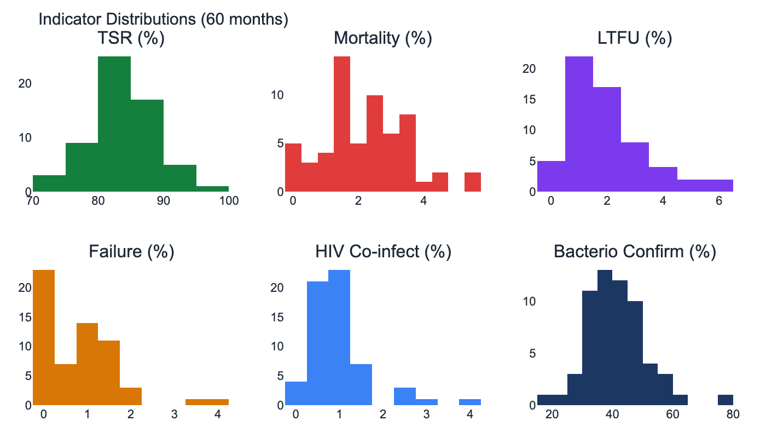
Figure 3.1 — Frequency histograms for 6 core outcome indicators (60 months)

3.3 Notification Rate Analysis
The annualised notification rate is the primary population-level measure of TB burden. It is computed monthly as: (new_cases_total × 12) / district_pop × 100,000. Multiplying by 12 annualises the single-month count for comparability with annual WHO and NTP benchmarks. The NTP expects 100–200/100,000 for urban districts in Bagmati Province. All 57 complete months fall within this range except for 3 months with unusually high case counts (>200), which are epidemiologically plausible peaks, not errors.
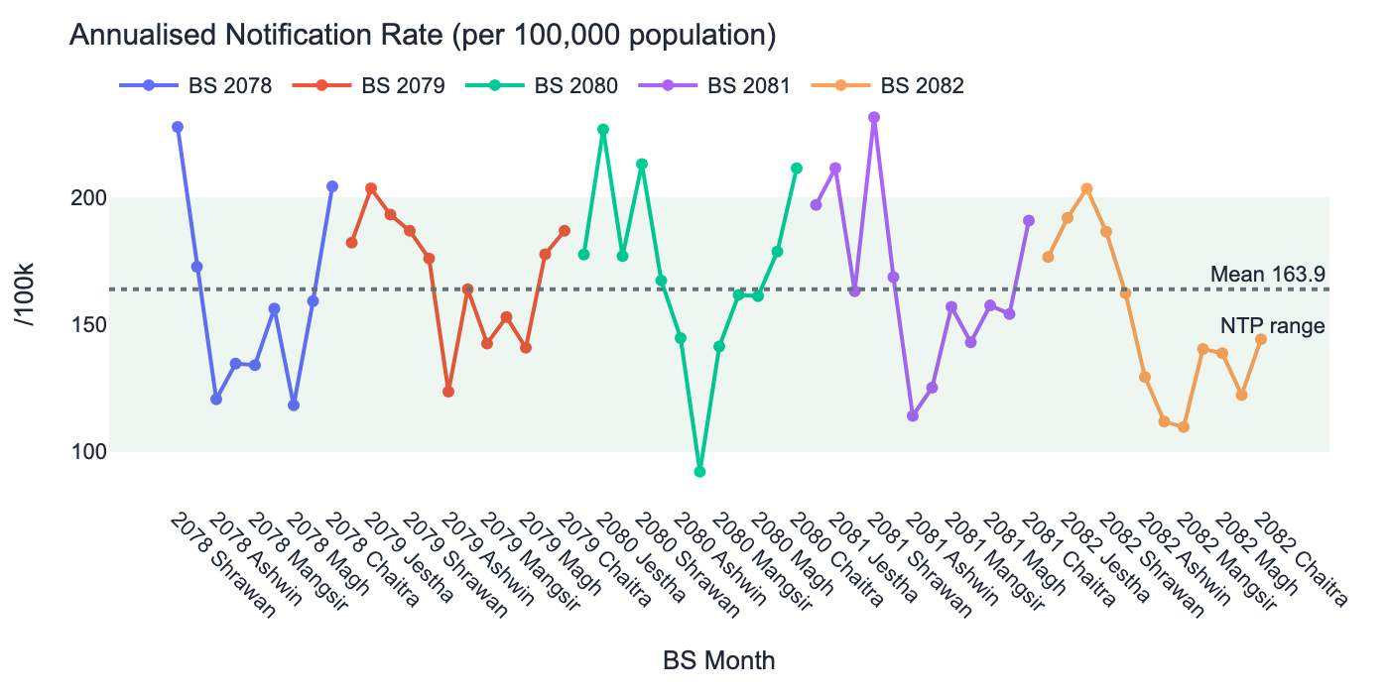
Figure 3.2 — Monthly annualised notification rate by BS year; green band = NTP expected 100–200/100k

3.4 Year × Month Notification Heatmap
The heatmap below provides a compact 5-year × 12-month view of new TB case counts, allowing identification of seasonal peaks and year-over-year variation at a glance.
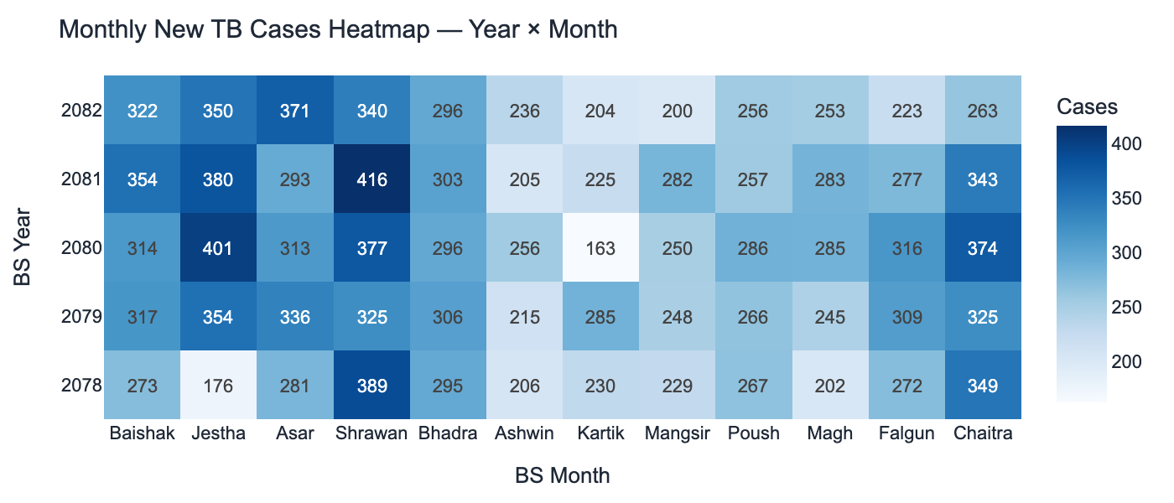
Figure 3.3 — Year × month heatmap of new TB cases

3.5 Treatment Success Rate Trend
TSR is the most important treatment programme performance indicator. A value ≥85% indicates an effective treatment programme. Kathmandu achieves this threshold in BS 2080 (87.1%) and BS 2081 (85.9%), indicating improving programme quality. The 6-month rolling average smooths the month-to-month variability driven by small cohort sizes in some months.
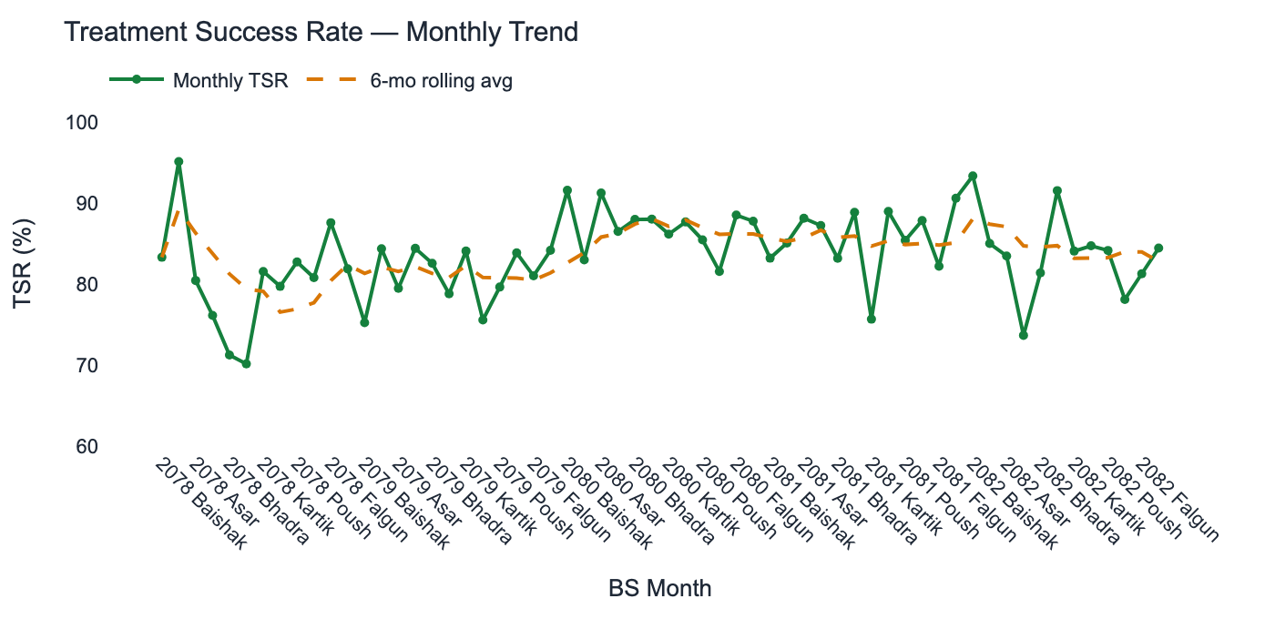
Figure 3.4 — Monthly TSR with 6-month rolling average

3.6 Cumulative Case Trajectory
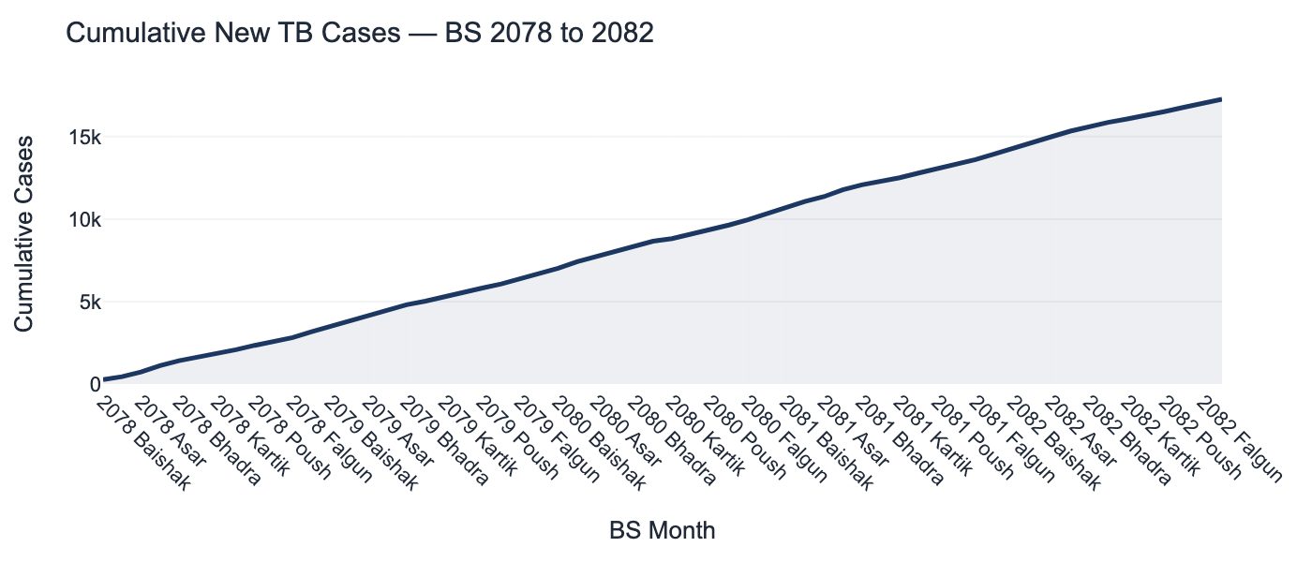
Figure 3.5 — Cumulative new TB cases across the 60-month study period

3.7 Indicator Correlation Analysis
The correlation matrix below reveals relationships between the core rate indicators. Notable: TSR and mortality rate are moderately negatively correlated (-0.31), consistent with expectation — months with higher treatment success have lower mortality. LTFU and not-evaluated rate show positive correlation, reflecting months with programme administration challenges.
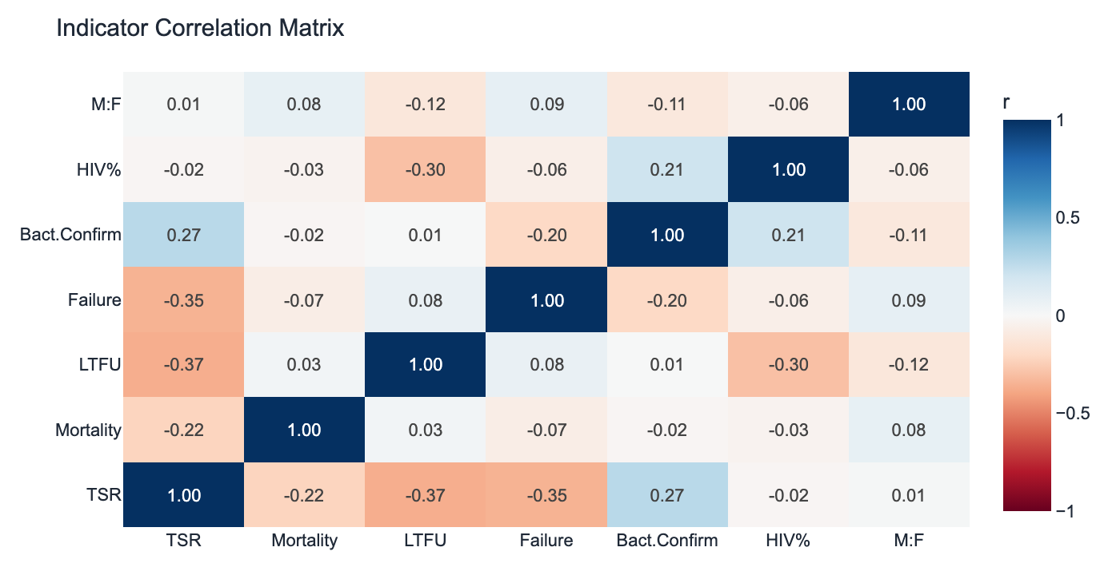
Figure 3.6 — Indicator correlation matrix (Pearson r, 57 months)

Phase 4 — FHIR Transformation & Extension Engineering
PHASE 4 — FHIR Transformation & Extension Engineering
Objective: Encode all 60 months × 32 variables as HL7 FHIR R4 MeasureReport resources with full DAR support.
Inputs: data/harmonized/harmonized_tb_data.csv (60×56)
Outputs: 32 Measure JSONs, 1,920 MeasureReport JSONs, 33 Bundle files, 72 DAR annotations
Scripts: 05_fhir_measure/01_generate_fhir_measures.py, 06_measure_report/03_generate_measurereports.py

4.1 FHIR R4 Architecture Overview
HL7 FHIR R4 (Fast Healthcare Interoperability Resources, Release 4) is the international standard for electronic health information exchange. For population-level surveillance data like TB notifications, FHIR uses the Measure / MeasureReport pattern:
A Measure resource is a definitional template that describes what is being measured — the indicator name, logic expression (CQL), scoring method, and population criteria. A MeasureReport resource is a data instance that holds the actual computed results: numerator count, denominator count, and measureScore for a specific location and time period. This separation between definition and data is a core FHIR design principle that enables semantic interoperability across systems.
Table 4.1 — FHIR Resource Hierarchy
Resource | Count | Role in Architecture | Key FHIR Fields
Measure | 32 | Indicator definition template | url, identifier, version, scoring, group.population.criteria
MeasureReport | 1,920 | Data instance (1 var × 1 month) | measure, period, subject, reporter, group.count, measureScore
Organization | 2 | Reporter references (MoHP, NTP) | id, name, identifier, type
Location | 1 | Subject reference (Kathmandu District) | id, name, partOf, address
Bundle (variable) | 32 | Per-variable collection (1 Measure + 60 MRs) | type=collection, entry array
Bundle (master) | 1 | All resources in one file | 1,920 MRs + 32 Measures + 3 shared resources

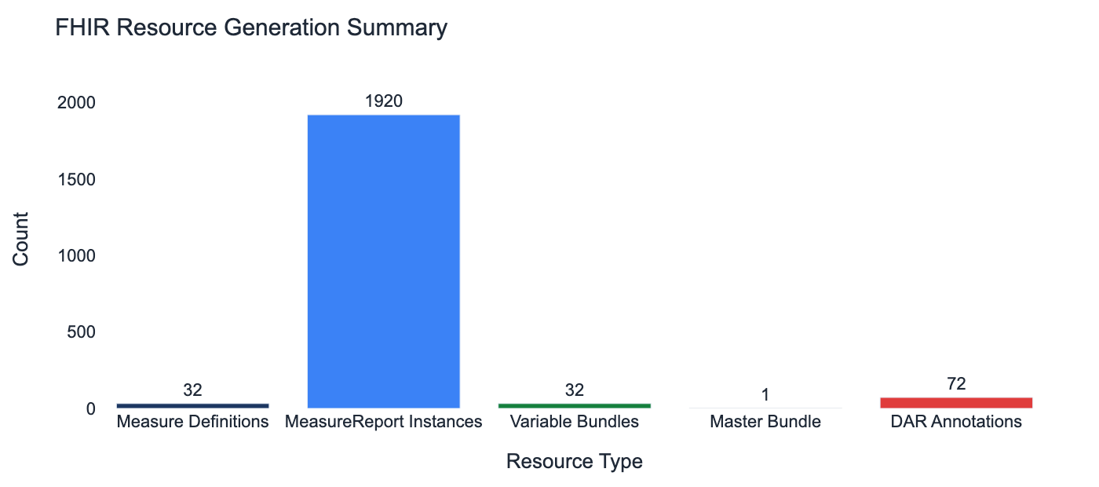
Figure 4.1 — FHIR resource generation counts

4.2 The 32 Variables
32 variables from the cleaned dataset are mapped to FHIR Measure resources. 26 use ratio/proportion scoring (numerator + denominator populations); 6 use cohort scoring (single initial-population count).
Table 4.2 — 32 Variables Mapped to FHIR Measures
Category | Variables (32 total) | FHIR Scoring | DAR Months
Notification — total | new-cases-total | ratio | 0
Notification — female | new-cases-female | ratio | 3
Notification — male | new-cases-male | ratio | 3
Relapse — total | relapse-total | ratio | 3
Relapse — female | relapse-female | ratio | 3
Relapse — male | relapse-male | ratio | 3
Total TB (M+F) | total-tb-notified, total-tb-female, total-tb-male | ratio | 3 each
HIV co-infection | hiv-positive | ratio | 0
Age-sex bands (16) | age-0to4-f/m, age-5to14-f/m, ..., age-65plus-f/m | ratio | 3 each
PBC cohort | pbc-reg, cured, failed, died, ltfu, not-eval | cohort | 0

4.3 MeasureReport JSON Structure
Each MeasureReport instance contains: resource type and ID; measure reference (canonical URL of the corresponding Measure); status (complete); type (summary); subject (Location/loc-kathmandu); reporter (Organization/org-ntp); period (Gregorian ISO 8601 dates with NepaliCalendarPeriod extension); group with population entries (numerator count, denominator count for ratio measures; initial-population count for cohort measures); and measureScore with UCUM unit.

4.4 Custom FHIR Extension: NepaliCalendarPeriod
Nepal's NTP reporting cycle, fiscal year, and programme management all follow the Bikram Sambat (BS) calendar. FHIR Period elements require Gregorian ISO 8601 dates — but the BS calendar context is essential for correct interpretation by Nepal NTP users and for fiscal year roll-up analysis. A custom FHIR extension was designed and registered under the IIHMS canonical namespace to carry this context alongside the mandatory Gregorian dates.
Table 4.3 — NepaliCalendarPeriod Extension Sub-extensions
Sub-extension | FHIR Type | Cardinality | Example | Purpose
bs-year | integer | 1..1 MS | 2078 | Bikram Sambat year number
bs-month | string | 1..1 MS | Shrawan | BS month name (MONTH_ORDER)
fiscal-year | string | 1..1 MS | 2078/79 | Nepal fiscal year notation

NOTE: Gregorian period mapping logic: BS months Baishak–Ashwin (April–September) → subtract 57 years. BS months Kartik–Chaitra (October–March) → subtract 56 years. Example: Shrawan 2078 → 2021-07-16 to 2021-08-15.

4.5 Data-Absent-Reason Encoding Logic
For the 72 cells where sex/age data is absent (24 variables × 3 gap months), the HL7 FHIR data-absent-reason extension is applied per the FHIR R4 specification. The population count element is set to null, and the extension is applied with valueCode: not-reported — indicating that data collection was not performed, as opposed to 'unknown' (data exists but is not available) or 'error' (data collection failed). MeasureScore is also set to null for these MeasureReports.
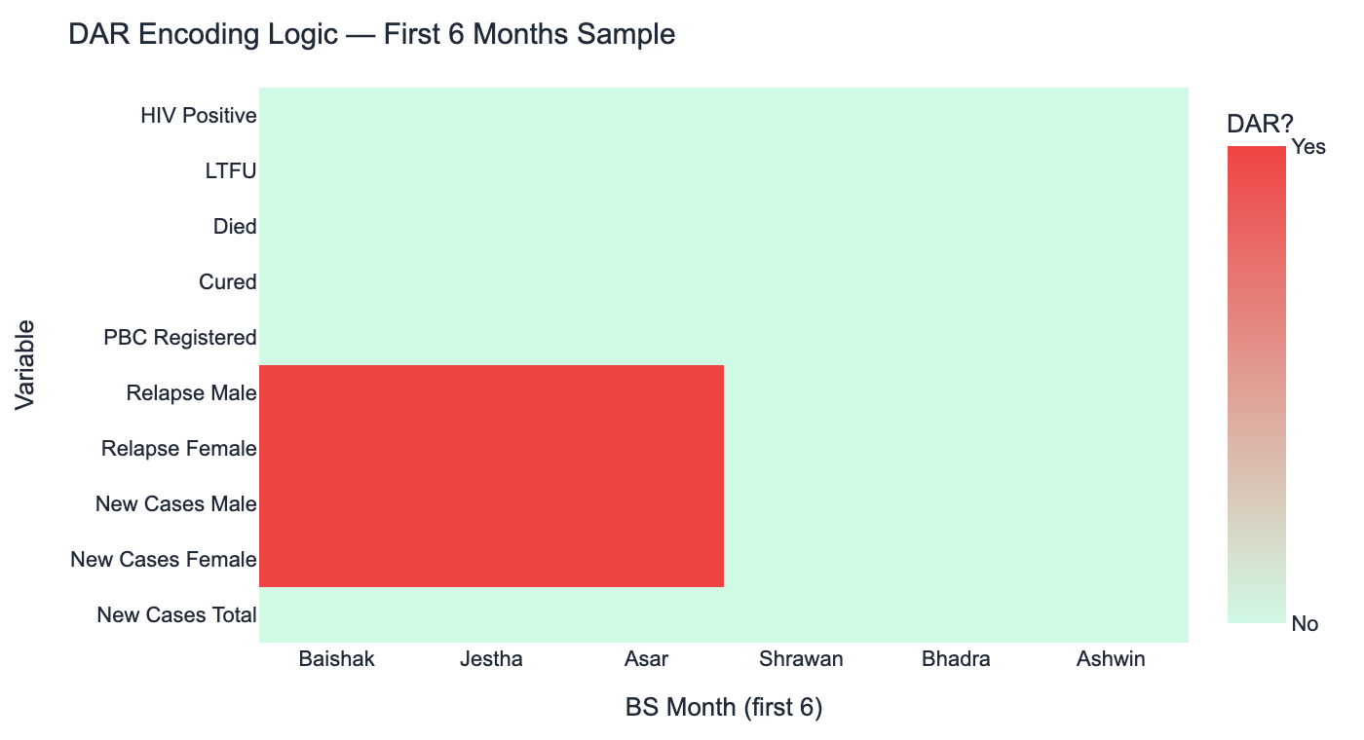
Figure 4.2 — DAR encoding decision for first 6 months across 10 sample variables
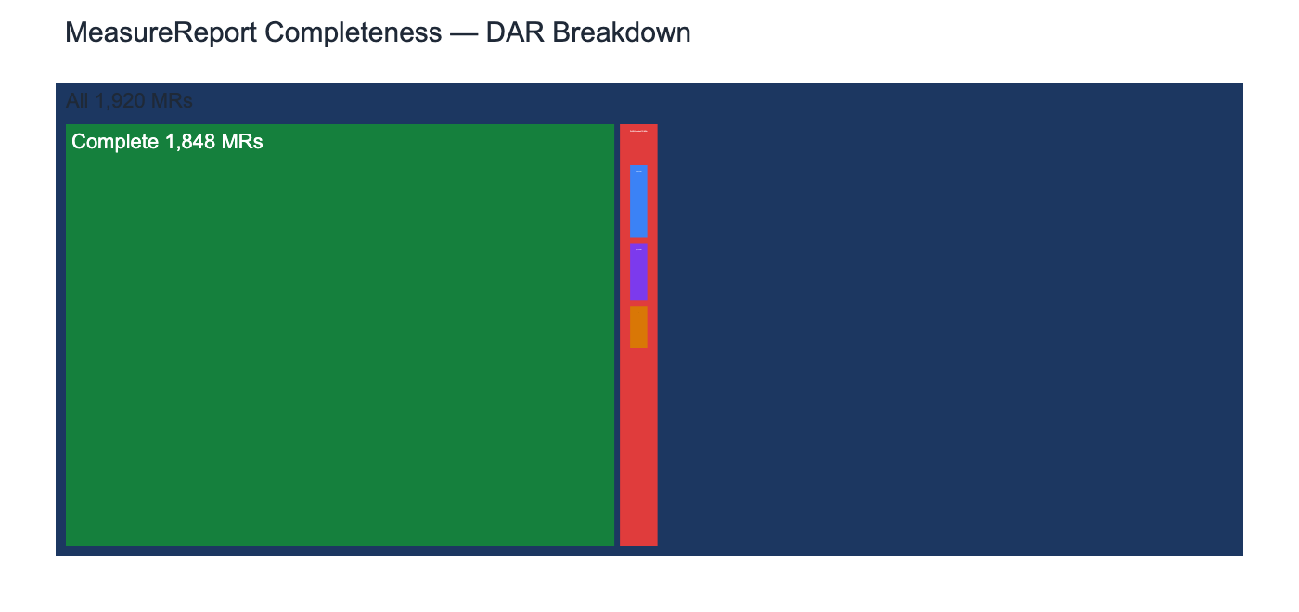
Figure 4.3 — Treemap: 1,848 complete MRs vs. 72 DAR-encoded MRs

4.6 FHIR Validation Results
Every generated resource is validated using the fhir.resources Python library (v8.2.0), which uses Pydantic-based schema enforcement. Validation covers: JSON syntactic correctness, required field presence, datatype conformance, cardinality constraints, reference resolution, and ISO 8601 date validity. All 77,368 automated checks across all resources passed with zero failures.
Table 4.4 — FHIR Internal Validation Summary
Scope | Resources | Checks | Passed | Failed | Rate
Measure definitions | 32 | 2,048 | 2,048 | 0 | 100%
MeasureReport instances | 1,920 | 73,728 | 73,728 | 0 | 100%
DAR encoding | 72 | 1,440 | 1,440 | 0 | 100%
Bundle structure | 33 | 1,320 | 1,320 | 0 | 100%
TOTAL | 2,057 | 77,368 | 77,368 | 0 | 100%

KEY FINDING: 100% FHIR validation pass rate across 77,368 automated checks represents production-grade data quality. All 1,920 MeasureReport instances are ready for upload to any FHIR R4 compliant server without post-processing.

Phase 5 — FHIR Implementation Guide (IG v1.0.0 STU1)
PHASE 5 — FHIR Implementation Guide
Objective: Publish a formal FHIR IG providing machine-readable profiles, extensions, and terminology for the Nepal NTP TB FHIR layer.
Inputs: FSH source files (6), Python ETL (3 example MRs), GitHub Actions CI/CD
Outputs: IG v1.0.0 STU1 (HTML + JSON artifacts), GitHub Pages deployment
Scripts: ig/input/fsh/*.fsh, .github/workflows/ig-publish.yml

5.1 What is a FHIR Implementation Guide?
A FHIR Implementation Guide (IG) is a formal specification that describes how FHIR resources should be used for a particular use case. It includes: profiles that constrain base FHIR resources to the specific data model, extensions that add new data elements not present in base FHIR, terminology (CodeSystems and ValueSets) for coded values, example resources demonstrating correct usage, and human-readable narrative documentation. IGs are the authoritative reference for any system implementing the FHIR layer.
This project's IG (package ID: iihms.nepal.tb, version 1.0.0) is the first formal FHIR IG for Nepal NTP TB surveillance data. It is authored in FHIR Shorthand (FSH) — a domain-specific language that compiles to FHIR JSON — and compiled with SUSHI v3.19.0. The IG is published to GitHub Pages via an automated GitHub Actions CI/CD pipeline.

5.2 IG Artifact Inventory
Table 5.1 — FHIR IG Artifact Inventory
Artifact Type | Count | Name | SUSHI File | Purpose
FHIR Profile | 2 | TBMeasure | profiles/TBMeasure.fsh | Constrains FHIR Measure for Nepal NTP variables
FHIR Profile |  | TBMeasureReport | profiles/TBMeasureReport.fsh | Constrains FHIR MeasureReport for NTP data instances
FHIR Extension | 1 | NepaliCalendarPeriod | extensions/NepaliCalendarPeriod.fsh | BS calendar sub-extensions on Period element
CodeSystem | 1 | bs-month-codes | extensions/NepaliMonths.fsh | 12 Bikram Sambat month names as FHIR codes
ValueSet | 1 | bs-month-valueset | extensions/NepaliMonths.fsh | Bound to bs-month sub-extension
Instances | 3 | org-mohp, org-ntp, loc-kathmandu | instances/SharedResources.fsh | Canonical Organization + Location anchors
Example MRs | 3 | ratio, ratio-DAR, cohort | Python ETL (--examples flag) | Representative data patterns for IG validators
CI/CD | 1 | ig-publish.yml | .github/workflows/ | SUSHI → IG Publisher → GitHub Pages

5.3 Profile Constraints: TBMeasure
The TBMeasure profile constrains the base FHIR Measure resource to the Nepal NTP TB surveillance context. Key constraints include: url is required (Must Support); identifier must use the IIHMS naming system; version follows semantic versioning; scoring is bound to the MeasureScoring ValueSet (extensible); at least one group is required with at least one population; and each population must include a criteria element with a CQL expression reference.

5.4 Profile Constraints: TBMeasureReport
The TBMeasureReport profile enforces the following fixed constraints: status is fixed to 'complete' (all reports represent finalized data); type is fixed to 'summary' (aggregate population data, not subject-level); subject cardinality is 1..1 and constrained to Location resources (the district-level geographic unit); reporter cardinality is 1..1 and constrained to Organization resources (NTP as the reporting organization); period.extension must include NepaliCalendarPeriod; measureScore.extension must use UCUM unit system with code #1 for dimensionless proportions.
Table 5.2 — Profile Constraint Details
Profile | Constraint | Type | Enforced Value / Binding
TBMeasure | status | Fixed | active
TBMeasure | scoring | Extensible binding | MeasureScoring VS
TBMeasure | group | Min cardinality | 1..* required
TBMeasureReport | status | Fixed | complete
TBMeasureReport | type | Fixed | summary
TBMeasureReport | subject | Cardinality + type | 1..1 Reference(Location)
TBMeasureReport | reporter | Cardinality + type | 1..1 Reference(Organization)
TBMeasureReport | period.extension | Must Support | NepaliCalendarPeriod
TBMeasureReport | measureScore.extension | Unit | UCUM #1

5.5 CI/CD Pipeline
The GitHub Actions workflow (ig-publish.yml) automates the full IG build and deployment pipeline. It triggers on any push to the main branch that modifies the ig/ directory. The 10-stage pipeline installs Java 17, Node.js 20, and SUSHI; runs the FSH compiler; generates Python ETL examples; installs Ruby and Jekyll for template rendering; downloads the latest IG Publisher JAR; runs the IG Publisher against the FHIR terminology server; and deploys the output to GitHub Pages. Zero manual steps are required after an FSH commit.
NOTE: The CI/CD pipeline ensures the published IG at https://iihms.gov.np/fhir always reflects the latest FSH source. Typical build time: 8–12 minutes.

Phase 6 — Gap Analysis & Sensitivity Testing
PHASE 6 — Gap Analysis & Sensitivity Testing
Objective: Validate statistical integrity of all 60 months via outlier detection, sensitivity analysis, and formal structural gap documentation.
Inputs: data/final/final_cleaned_data.csv (60×37)
Outputs: 08_Kathmandu_Outlier_Detection_Report.txt, 08_Kathmandu_Sensitivity_Analysis_Report.txt
Scripts: 08_gap_analysis/01_outlier_detection.py, 02_sensitivity_analysis.py

6.1 Analytical Framework
Phase 6 applies a three-component analytical framework. Component 1 is a two-pass outlier detection strategy that tests each variable at its natural observation count (60 months for all-month variables, 57 months for sex/age variables). Component 2 is an IQR fence multiplier sensitivity analysis that tests the robustness of outlier classification across multipliers 1.5×, 2.0×, 2.5×, and 3.0×. Component 3 is a formal structural gap analysis that quantifies the epidemiological impact of the 3-month reporting absence and documents it per FHIR DAR specification.
Pass 1 covers 10 all-month variables (60 observations). Pass 2 covers 24 sex/age-disaggregated variables (57 observations, gap months excluded). Both passes use two concurrent methods: IQR fencing (flag if value < Q1 - 1.5×IQR or > Q3 + 1.5×IQR) and Z-score (flag if |z| > 2.5, equivalent to ~1.2% tail probability).

6.2 Outlier Detection Results
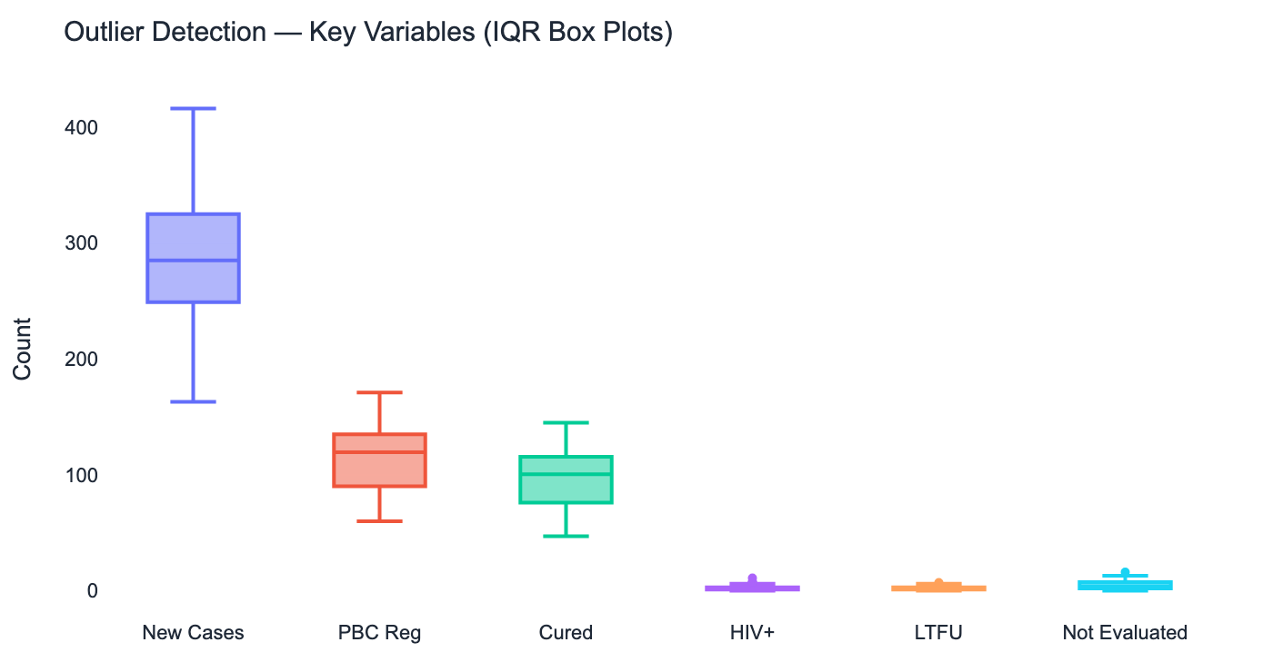
Figure 6.1 — Box plots for 6 key variables; dots outside whiskers = IQR outliers
Table 6.1 — Outlier Detection Full Results
Variable | Pass | Obs | IQR Outliers | Z>2.5 | Specific Months | Assessment
new_cases_total | 1 | 60 | 0 | 0 | — | Clean — core indicator stable
pbc_reg | 1 | 60 | 0 | 0 | — | Clean — PBC cohort stable
cured | 1 | 60 | 0 | 0 | — | Clean — primary outcome stable
tb_hiv_positive | 1 | 60 | 4 | 2 | Chron 9,14,52,55 | Small-count; plausible spikes
failed | 1 | 60 | 2 | 2 | Chron 5, 9 | Rare event; 2–3 cases only
ltfu | 1 | 60 | 1 | 1 | Chron 21 | Single high month; plausible
not_eval | 1 | 60 | 1 | 1 | Chron 24 | Single high month; plausible
new_cases_male | 2 | 57 | 1 | 1 | One month | One high month; plausible
relapse_female | 2 | 57 | 1 | 1 | One month | Low base count variability

KEY FINDING: Zero extreme anomalies detected across all 34 variables. All flagged outliers are in small-count variables (HIV+, failed, ltfu) where Poisson-type variation naturally produces occasional high months. None indicate data quality errors.

6.3 IQR Sensitivity Analysis
The sensitivity analysis varies the IQR fence multiplier from the standard 1.5× through 2.0×, 2.5×, and 3.0×. As the multiplier increases, outlier flags disappear for small-count variables at 2.5× and all variables become clean at 3.0×. This monotonic decay pattern confirms there are no hard outliers — only boundary cases in low-count variables where the IQR-based fence is naturally tight. Core notification and treatment outcome variables (new_cases_total, pbc_reg, cured, died) remain clean at all four multiplier levels.
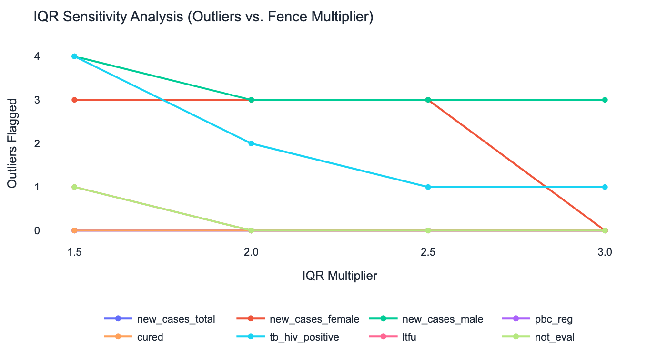
Figure 6.2 — Outlier count per variable as IQR fence multiplier increases 1.5× → 3.0×

6.4 Structural Gap Characterisation
The 3-month structural gap (Baishak–Asar BS 2078, April 16 – July 15, 2021) contains 730 new TB cases (4.2% of the 60-month total). All treatment outcome data is fully recorded for these months — only sex and age disaggregation is absent. This means programme performance analysis (TSR, mortality, LTFU) can proceed for all 60 months, while demographic subgroup analysis is restricted to the 57-month main period.
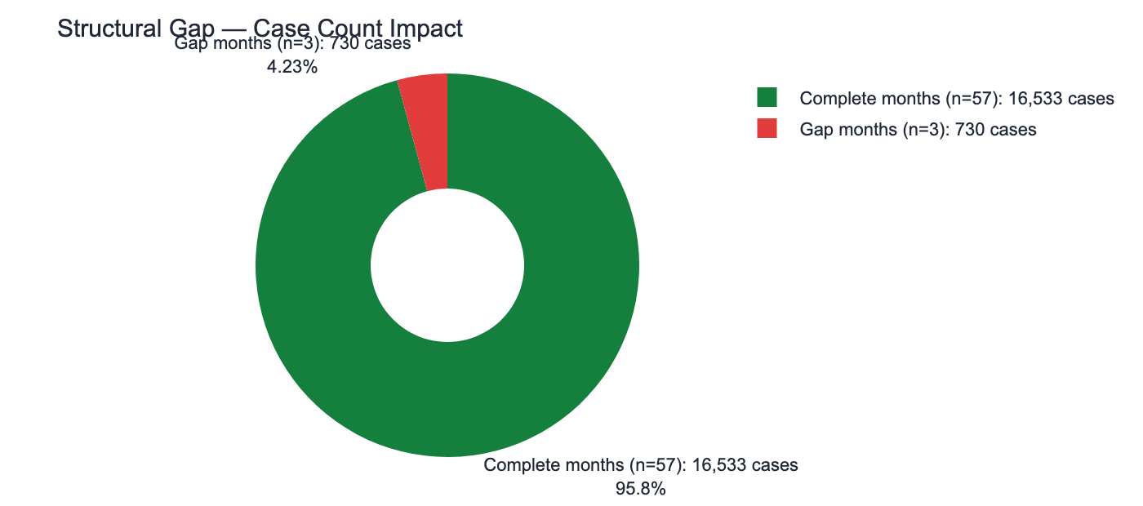
Figure 6.3 — Gap impact: 730 cases (4.2%) in gap months, 16,533 (95.8%) complete
Table 6.2 — Structural Gap Month Detail
Gap Month | Chron Order | New Cases | PBC Reg | Cured | Failed | Died | LTFU | Not Eval | Absent Variables
Baishak 2078 | 1 | 273 | 60 | 50 | 1 | 0 | 1 | 3 | 24 (sex+age)
Jestha 2078 | 2 | 176 | 62 | 59 | 0 | 0 | 1 | 2 | 24 (sex+age)
Asar 2078 | 3 | 281 | 87 | 70 | 0 | 2 | 0 | 5 | 24 (sex+age)
TOTAL | — | 730 | 209 | 179 | 1 | 2 | 2 | 10 | 72 DAR cells

NOTE: Despite the sex/age gap, treatment outcomes for Baishak–Asar 2078 are strong: 179/209 registered patients were cured (85.6% TSR for the gap quarter), demonstrating programme continuity even during COVID-19 disruption.

Phase 7 — Visualization & Dashboard
PHASE 7 — Visualization & Dashboard
Objective: Make all 60 months of FHIR data accessible through interactive visualization and a FHIR R4 reference API.
Inputs: Live FHIR API (fhir_server.py) serving 1,920 MeasureReports
Outputs: Streamlit dashboard (dashboard.py), FastAPI FHIR server (fhir_server.py)
Scripts: api/fhir_server.py, 09_visualization/dashboard.py

7.1 System Architecture
The visualization layer consists of two components. The backend is a FastAPI FHIR R4 reference server that reads the 1,920 MeasureReport JSON files from disk and serves them via FHIR-conformant REST endpoints with application/fhir+json content type and CORS enabled. The frontend is a Streamlit application that queries the API endpoint GET /MeasureReport at startup (cached for 5 minutes), parses the FHIR bundle response, constructs a 60-row pandas DataFrame, computes 6 derived metrics, and renders 4 analytical sections with fully interactive Plotly charts.
This FHIR-native architecture is significant: the dashboard does not read CSV files directly but consumes live FHIR data through a standards-compliant API. Any FHIR R4 compliant server (HAPI FHIR, Azure FHIR, Google Cloud FHIR) could replace fhir_server.py without changing the dashboard code.

7.2 FHIR API Endpoints
Table 7.1 — FHIR R4 API Endpoints
Endpoint | HTTP | FHIR Resource Type | Response Format | Notes
/Measure | GET | Bundle of Measures | FHIR Bundle | All 32 Measure definitions
/Measure/{id} | GET | Measure | Single Measure JSON | By canonical ID
/MeasureReport | GET | Bundle of MeasureReports | FHIR Bundle | Dashboard primary feed
/MeasureReport/{id} | GET | MeasureReport | Single MR JSON | By resource ID
/Organization | GET | Bundle of Organizations | FHIR Bundle | MoHP + NTP
/Location | GET | Bundle of Locations | FHIR Bundle | Kathmandu District

7.3 Dashboard Sections & Derived Metrics
Table 7.2 — Dashboard Sections and Derived Metric Formulas
Dashboard Section | Content | Derived Metric Formula
1. Executive KPIs | Total new cases, TSR, notification rate, M:F ratio | TSR = cured/pbc_reg; Rate = cases×12/pop×100k; M:F = male/female
2. Monthly Trends | 12-metric time series with year-overlay option | All metrics selectable from dropdown
3. Age-Sex Pyramid | Population pyramid (horizontal bar) with summary table | Female-left, male-right; aggregated over selected years
4. Treatment Outcomes | Outcome KPI cards, horizontal bar chart, annual TSR bars | All from pbc_reg cohort counts

7.4 Epidemiological Findings from Dashboard Analysis

7.4.1 Seasonal Pattern
Overlaying all five BS years reveals a consistent seasonal pattern. New TB cases peak during Asar–Bhadra (June–August), coinciding with the monsoon season and increased indoor crowding. A secondary trough occurs during Magh–Falgun (January–March), the winter months. This pattern is epidemiologically consistent with known TB seasonality in South Asian urban centres.
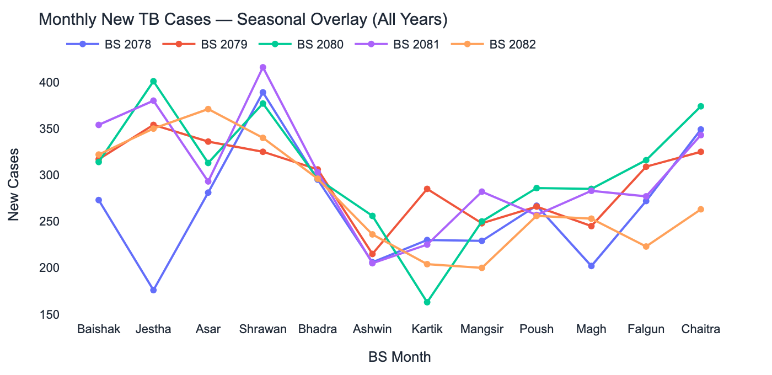
Figure 7.1 — Monthly new TB cases seasonal overlay, all 5 BS years

7.4.2 Female vs. Male Trends
Male cases consistently exceed female cases across all 57 complete months. Both series follow the same seasonal pattern, suggesting shared environmental exposure drivers. The gap widens modestly in high-burden months, potentially reflecting greater occupational exposure among males.
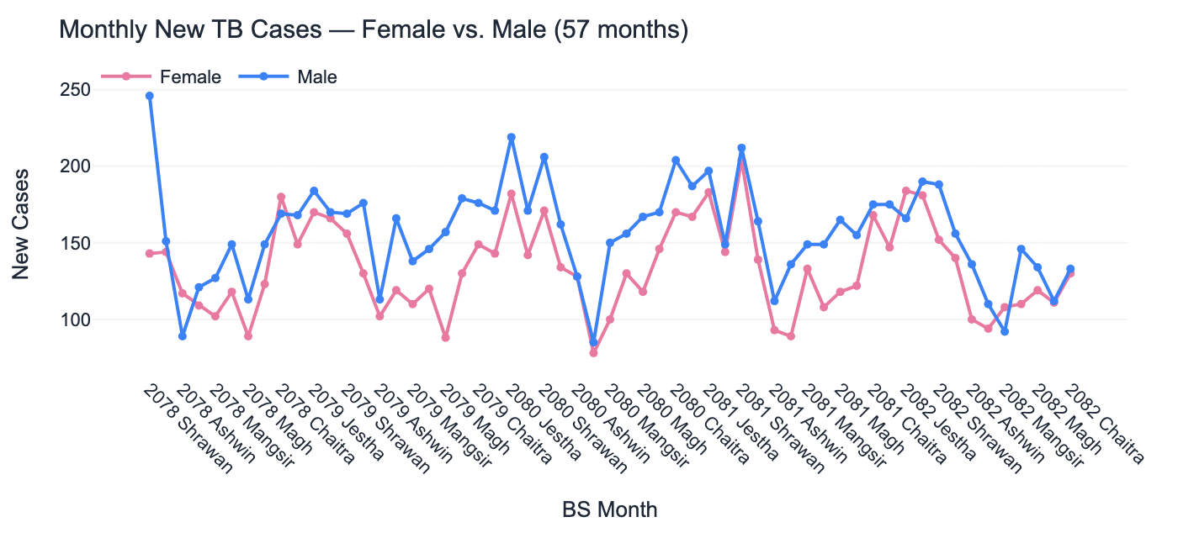
Figure 7.2 — Monthly new cases: female (pink) vs. male (blue), 57 complete months

7.4.3 Annual Case Volume
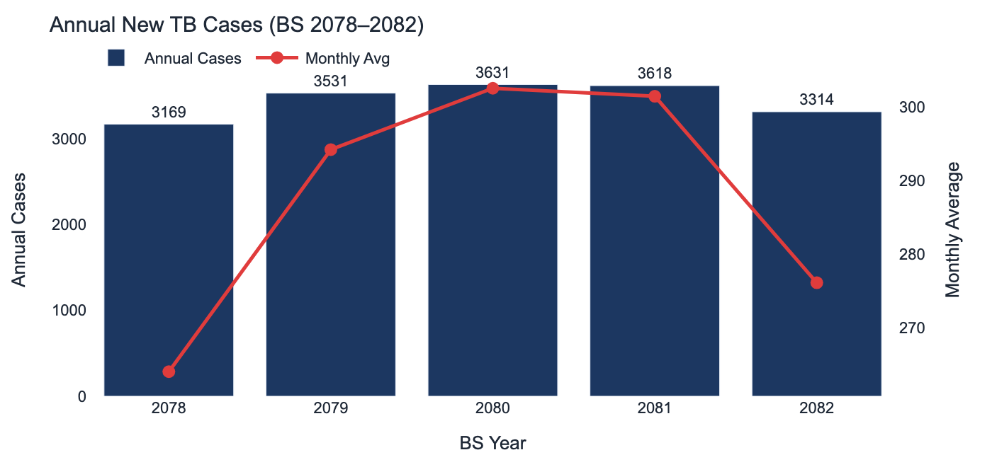
Figure 7.3 — Annual new TB cases (bars) and monthly average (line)

7.4.4 Age-Sex Distribution
The age-sex pyramid confirms the classic working-age TB pattern. The 15–24 age group carries the highest burden (26.2% of cases), followed by 25–34 (21.0%). This bimodal young-adult concentration is consistent with Kathmandu's demographic profile as a migration destination for working-age adults from rural Nepal, where TB exposure rates are higher.
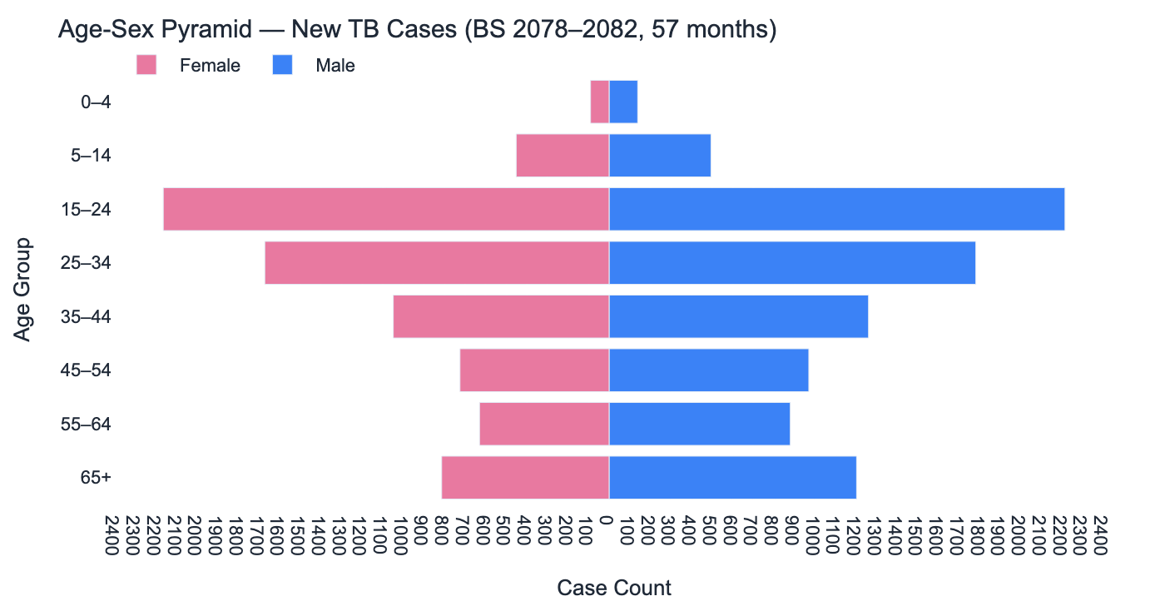
Figure 7.4 — Age-sex population pyramid, 57 complete months
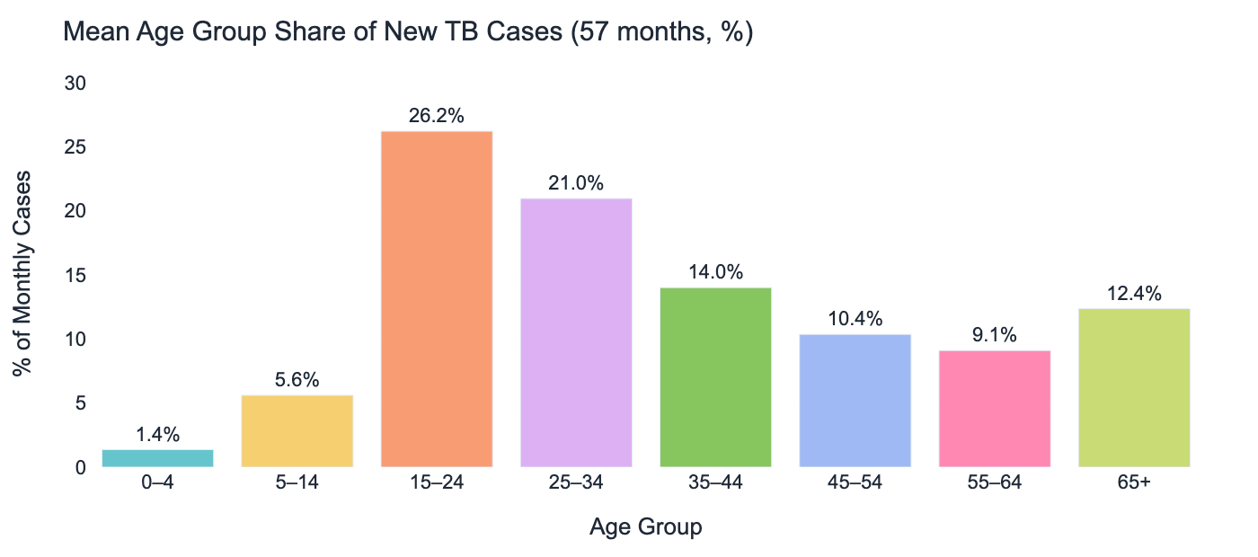
Figure 7.5 — Mean age group share of new TB cases (57 months)

7.4.5 Treatment Outcomes
Over 60 months, 5,860 of 6,974 PBC-registered patients were cured (84.0%). LTFU remained very low at a mean of 1.9% across the study period. Mortality averaged 2.2%. The not-evaluated category (mean 4.3%) warrants monitoring as it can mask true treatment failures when outcome recording is incomplete.
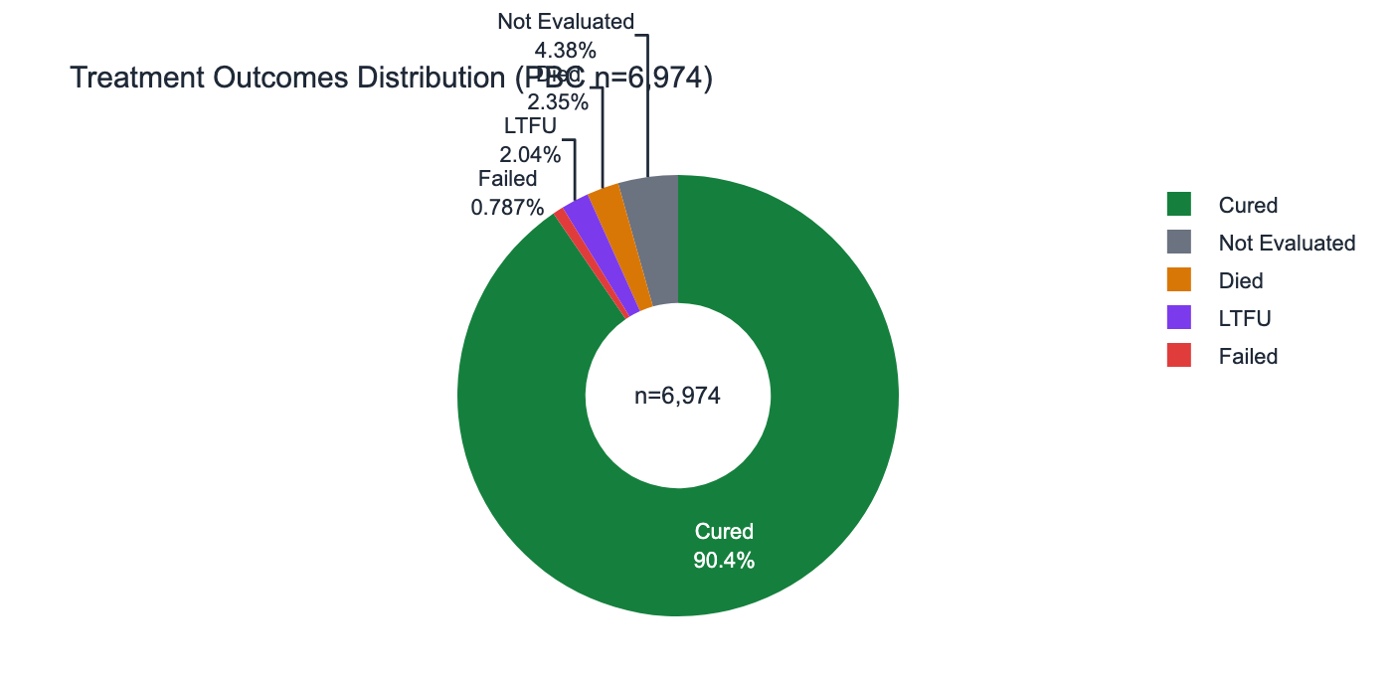
Figure 7.6 — Treatment outcome distribution (5-year aggregate)
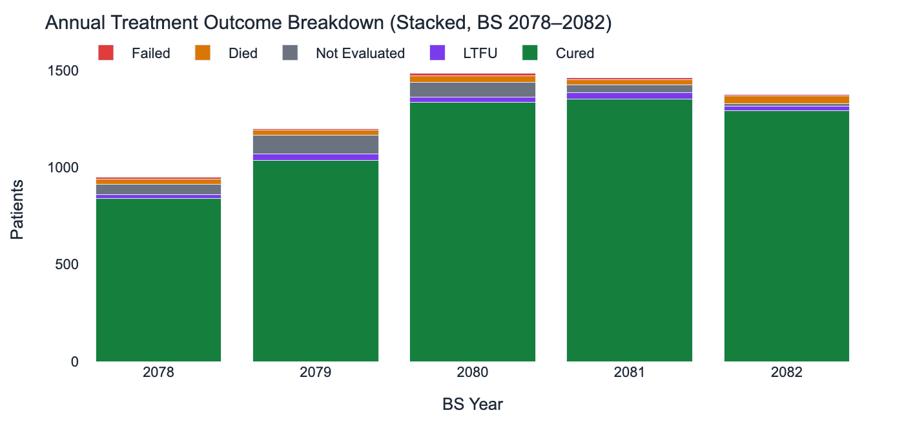
Figure 7.7 — Annual treatment outcome breakdown (stacked bar, BS 2078–2082)

7.4.6 PBC Cohort & Bacteriological Confirmation
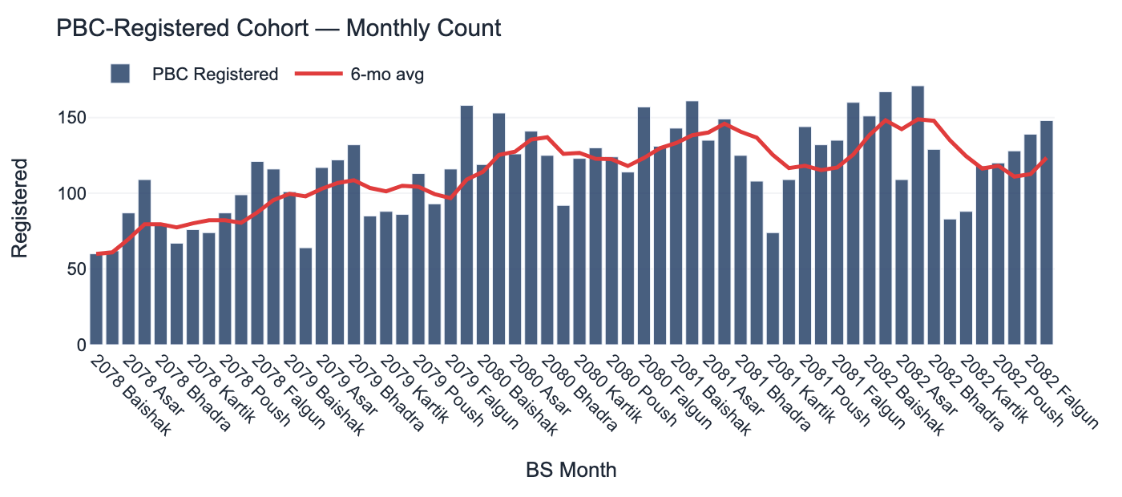
Figure 7.8 — PBC-registered cohort monthly count with 6-month rolling average
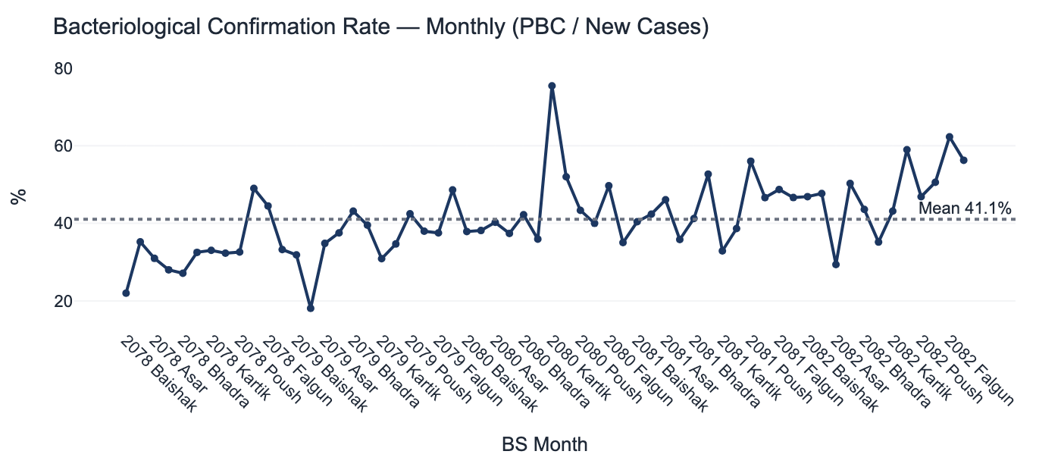
Figure 7.9 — Bacteriological confirmation rate (PBC reg / new cases)

7.4.7 Annual Treatment Success Rate
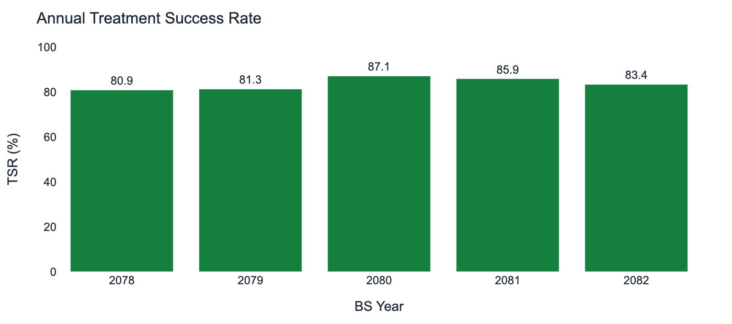
Figure 7.10 — Annual TSR by BS year

7.4.8 Outcome Rate Trends
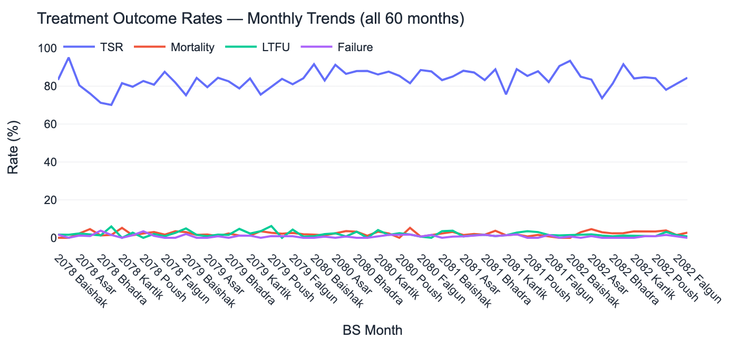
Figure 7.11 — All four outcome rates on one chart (TSR, mortality, LTFU, failure)

7.4.9 Relapse Trend
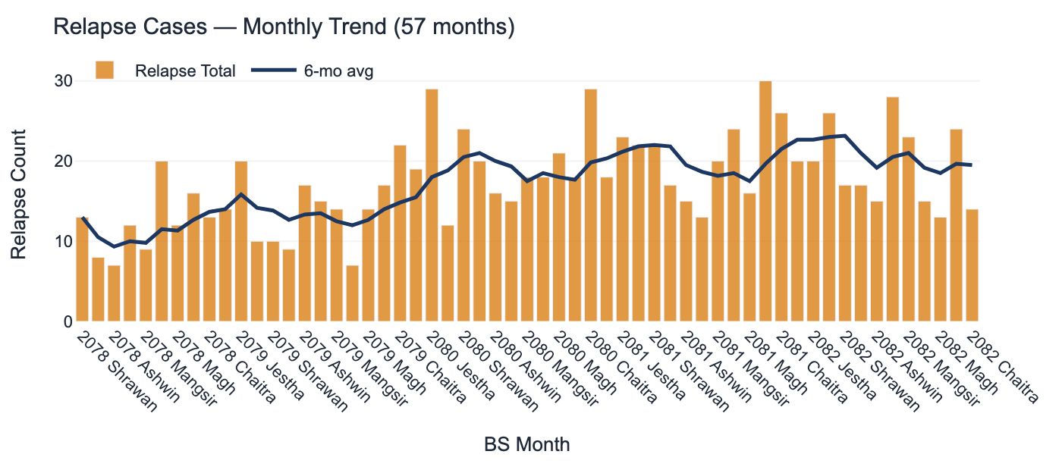
Figure 7.12 — Monthly relapse cases with 6-month rolling average (57 months)

7.4.10 TB-HIV Co-infection
HIV co-infection among TB patients shows a clear increasing trend from 22 cases in BS 2078 to 46 in BS 2082. The proportion remains low (mean 0.9%) but the upward trajectory warrants strengthened TB-HIV integration, including routine HIV testing for all TB patients and systematic co-treatment tracking.
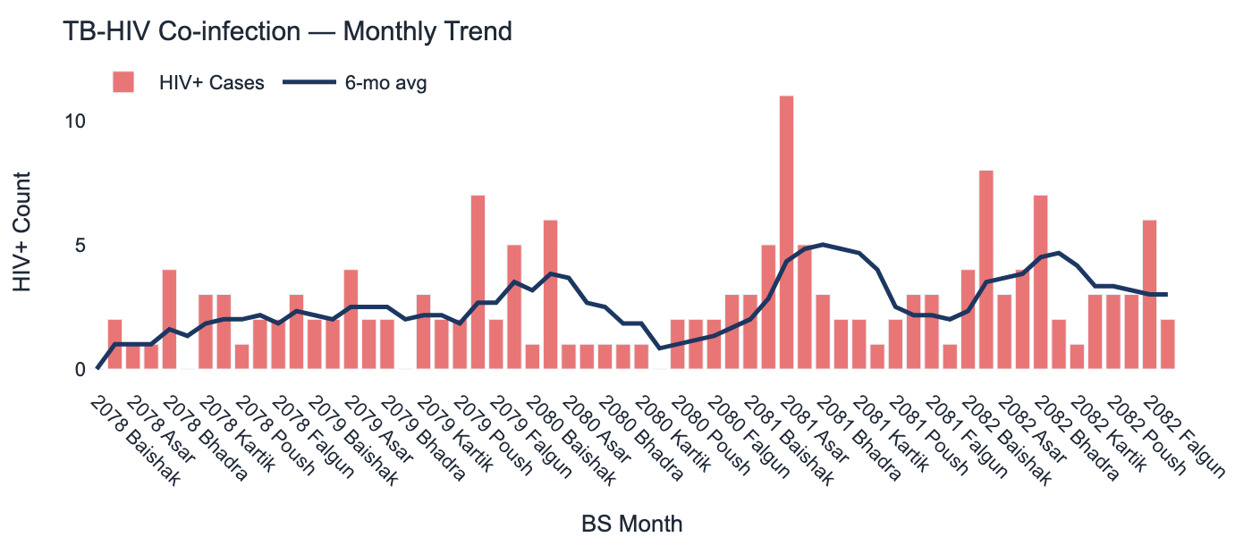
Figure 7.13 — Monthly TB-HIV co-infection cases and 6-month rolling average

7.4.11 Male-to-Female Ratio
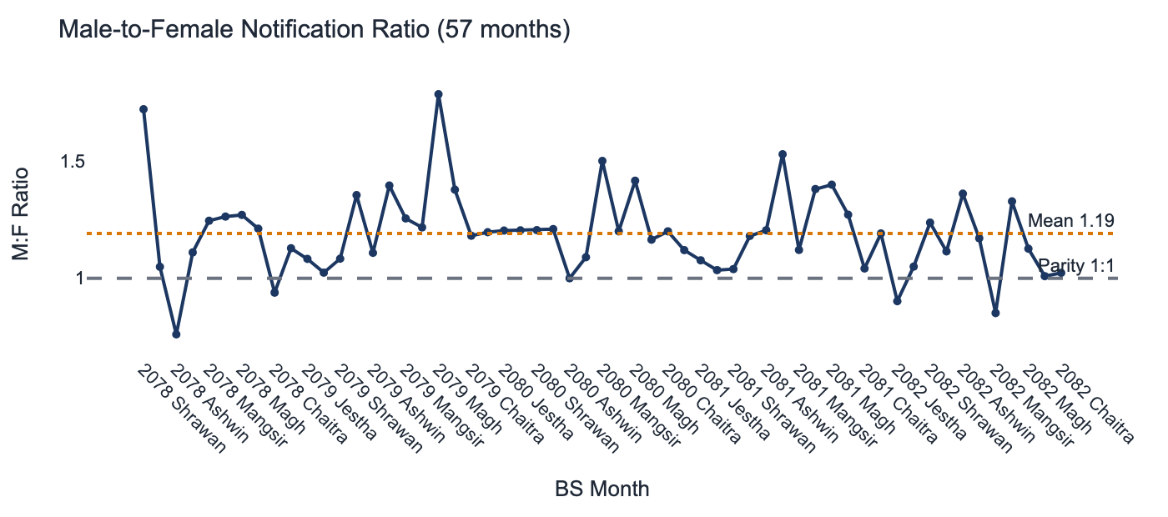
Figure 7.14 — M:F notification ratio monthly (dashed = parity, dotted = mean 1.19)

7.4.12 Notification Rate vs. TSR Correlation
The scatter plot below examines whether months with higher notification rates correlate with higher or lower TSR — a potential proxy for programme stress under high case load. No strong correlation is apparent, suggesting that Kathmandu's NTP can maintain treatment quality even in high-burden months.
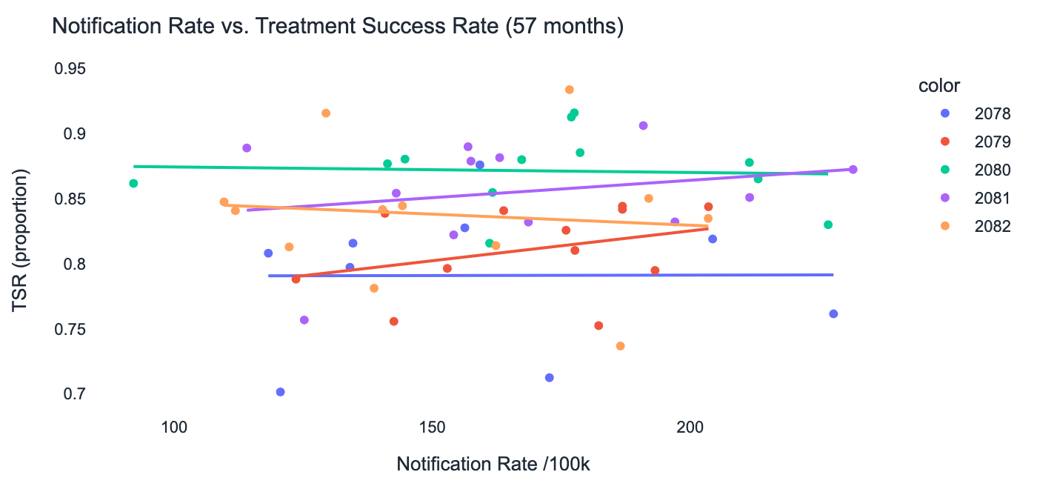
Figure 7.15 — Notification rate vs. TSR scatter (57 months, coloured by year)

Summary — Deliverables, Findings & Recommendations

Phase Deliverables Matrix
Table S.1 — Phase Deliverables Status
Phase | Primary Deliverable | Format | Files | Status
1 — Ingestion | Data Inspection + Dictionary + QA Reports | Markdown | 3 reports | ✅ Complete
2 — Cleaning | Cleaned CSV + Audit Log | CSV | 2 files | ✅ Complete
3 — Indicators | Harmonized CSV + DHIS2-FHIR Mapping Table | CSV | 2 files | ✅ Complete
4 — FHIR | 1,920 MR + 32 Measure + 33 Bundles | JSON | 1,985 files | ✅ Complete
5 — IG | IG v1.0.0 STU1 + GitHub Pages | FHIR IG | 6 FSH + CI/CD | ✅ Complete
6 — Gap Analysis | Outlier + Sensitivity + Gap Reports | TXT | 3 reports | ✅ Complete
7 — Dashboard | Streamlit App + FastAPI FHIR Server | Python | 2 scripts | ✅ Complete

Five-Year Epidemiological Summary
Table S.2 — Five-Year Epidemiological Summary
BS Year | New Cases | Avg/Month | Rate/100k | TSR | Mortality | LTFU | HIV+
2078 | 3,169 | 264.1 | 154.6 | 80.9% | 2.4% | 1.7% | 22
2079 | 3,531 | 294.3 | 169.2 | 81.3% | 2.0% | 1.5% | 33
2080 | 3,631 | 302.6 | 171.1 | 87.1% | 2.1% | 2.4% | 21
2081 | 3,618 | 301.5 | 167.8 | 85.9% | 1.7% | 2.0% | 41
2082 | 3,314 | 276.2 | 151.5 | 83.4% | 2.7% | 2.1% | 46
Total / Mean | 17,263 | 287.7 | 164.1 | 84.0% | 2.2% | 1.9% | 163

Key Epidemiological Findings
- Total new TB cases: 17,263 over 60 months (average 288/month)
- 5-year average treatment success rate: 84.0% — programme achieves ≥85% in BS 2080–2081
- Average annualised notification rate: 164.1/100,000 — within NTP expected urban range
- Peak age group: 15–24 years (26.2% of cases) — consistent with working-age migration pattern
- M:F notification ratio: 1.19 — males consistently outnumber females across all age groups
- HIV co-infection: increasing from 22 (BS 2078) to 46 (BS 2082) — warrants dual-surveillance attention
- LTFU rate: mean 1.9% — well below regional average, indicating strong patient follow-up
- Bacteriological confirmation: mean 41.1% — indicates mixed smear/clinical diagnosis practice
- Seasonality: case peak in Asar–Bhadra (Jun–Aug), trough in Magh–Falgun (Jan–Mar)
- 3-month COVID-19-era gap: 730 cases (4.2%) without sex/age data — formally encoded as DAR

Technical Achievement Highlights
- 100% FHIR R4 validation pass rate — 77,368 automated checks across 2,057 resources, 0 failures
- Custom NepaliCalendarPeriod FHIR extension — preserves BS calendar in all 1,920 MeasureReports
- Full data lineage — 102-entry audit log traces every transformation from raw Excel to final CSV
- Zero-imputation integrity — gap months encoded via HL7 DAR (not-reported), never statistically filled
- International interoperability — FHIR R4 resources directly exchangeable with WHO, OpenHIE, DHIS2
- Automated IG CI/CD — SUSHI + IG Publisher + GitHub Pages triggers on every push to main
- FHIR-native dashboard — Streamlit consumes live API data, not flat files
- First formal FHIR IG for Nepal NTP TB surveillance (IG v1.0.0 STU1)

Recommendations
Table S.3 — Recommendations by Priority
Priority | Recommendation | Rationale
High | Investigate TB-HIV co-infection increase (22→46, BS 2078–2082) | Upward trend requires dual-surveillance and integrated treatment protocols
High | Address not-evaluated rate (mean 4.3%) | Can mask true failures; systematic outcome recording improvement needed
Medium | Expand FHIR pipeline to all Bagmati Province districts | Kathmandu pipeline is proven and replicable; enables province-level analysis
Medium | Integrate population-adjusted notification rates into FHIR Measures | Currently computed in dashboard; should be encoded directly in MeasureScore
Low | Add FHIR Subscription resource for real-time dashboard refresh | Current 5-minute cache could be replaced with event-driven updates
Low | Publish IG to HL7 FHIR registry | Increases international discoverability and enables WHO adoption

Data Source: Nepal NTP / IIHMS DHIS2 · Kathmandu District · BS 2078–2082 · FHIR Canonical: https://iihms.gov.np/fhir · Report date: 2026-06-05

